**Advanced Web Programming – Migration, Seeder, DB Façade, Query Builder and Eloquent ORM**

**Week 3**



**Baskoro Seno Aji**

**2341720063 / 05 / TI-2I**

**Github Link :** [**Github**](https://github.com/Anothaatype/University/tree/main/Semester-4/Pemrograman-Web-Lanjut/Week-3/PWL_POS)

**Polytechnic State of Malang**

**Pengaturan Database**

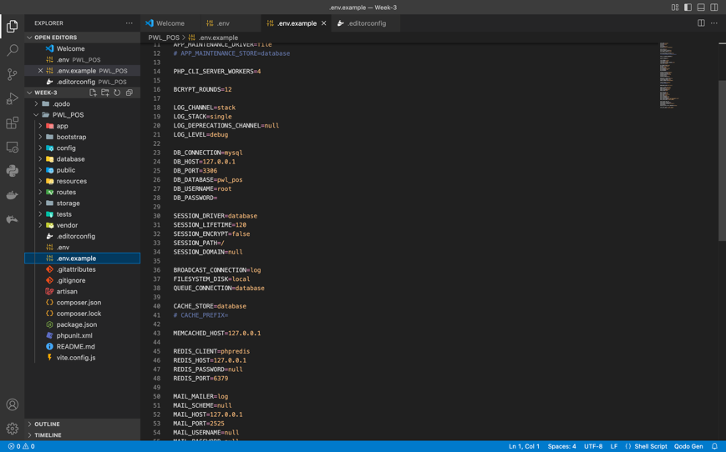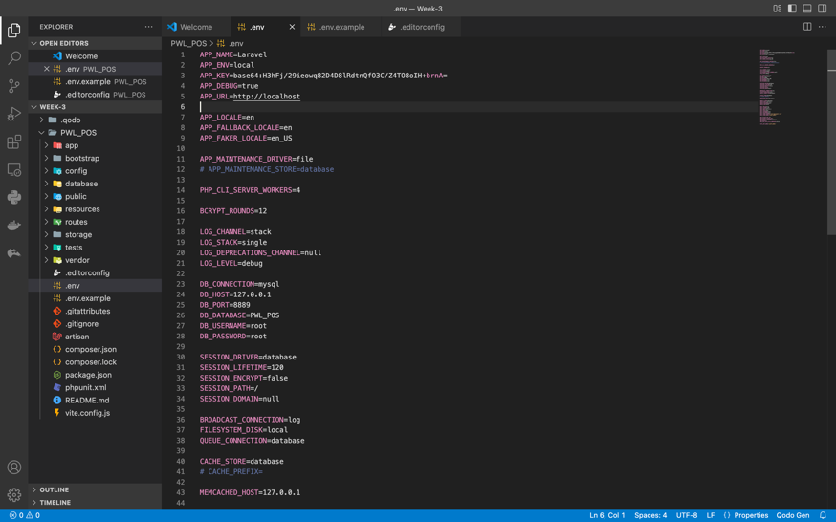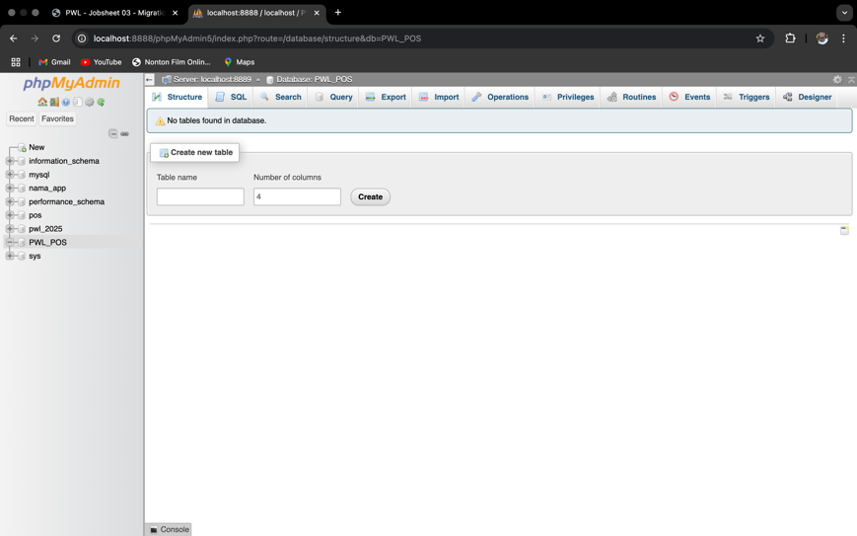**Praktikum 1 :**

1. This section we’re creating the databases first on the PhpMyAdmin then implement the database into the PWL_POS folder where it already installed by the Laravel and recheck it into the VSCode by specifically see the DB PORT, APP KEY, DB DATABASE, and change the DB PASSWORD.

**MIGRATION**

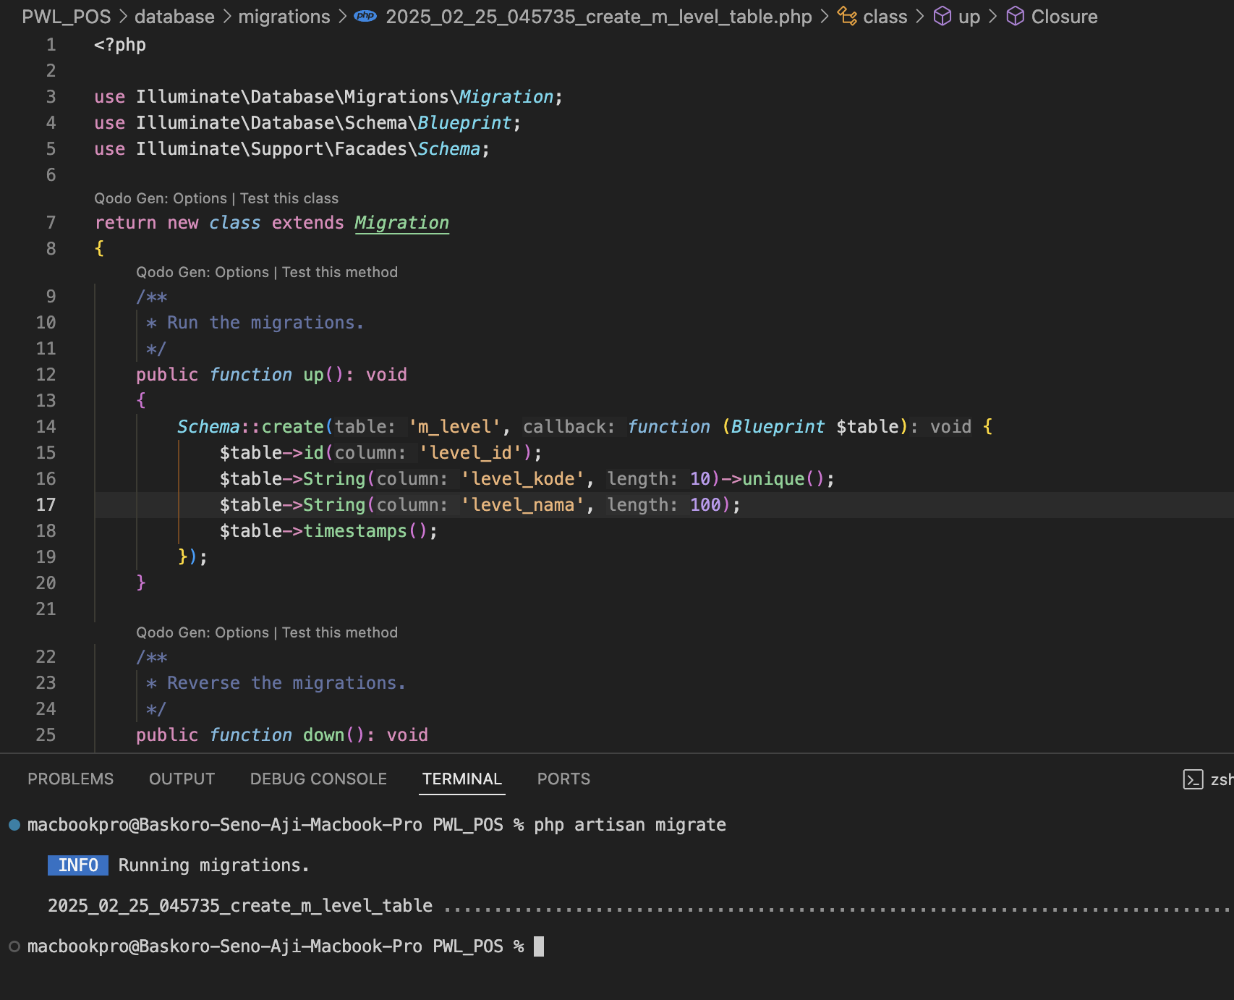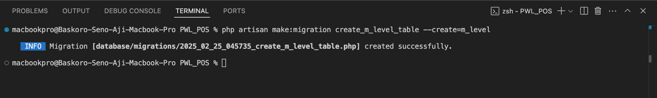**Praktikum 2.1 – Pembuatan File Migrasi Tanpa Relasi**

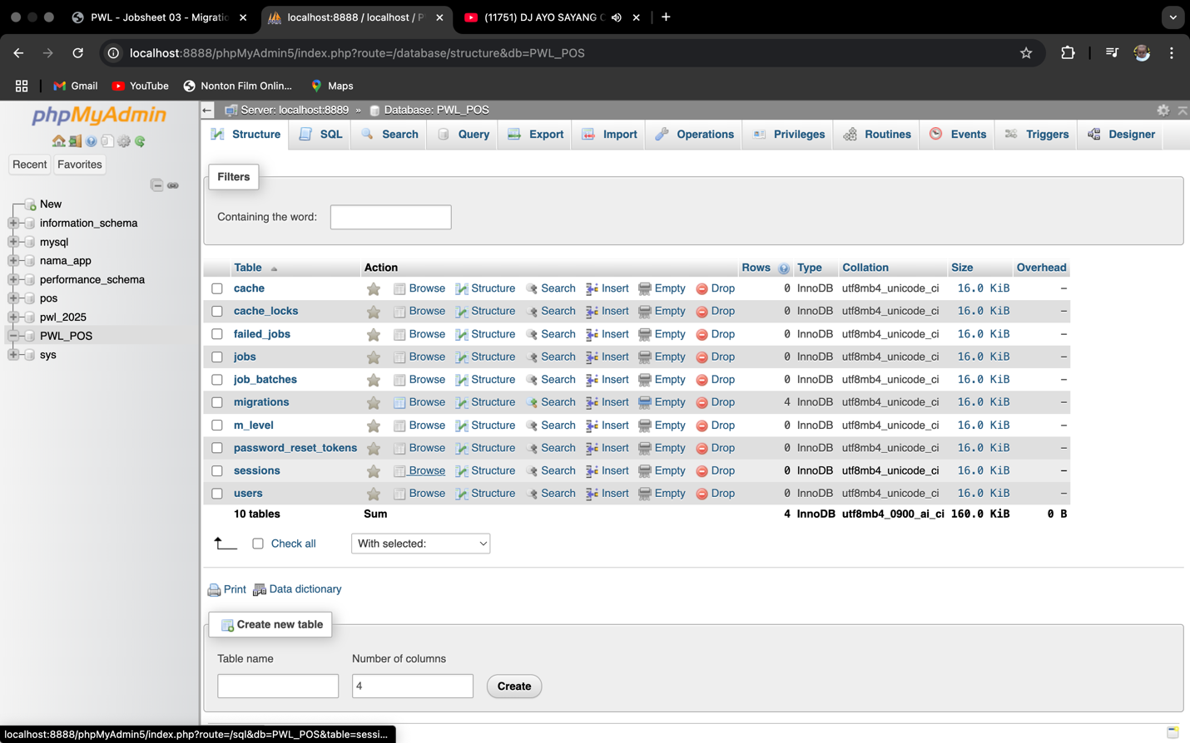

1. in this section we’re implementing the **MIGRATIONS** for table who doesn’t have the foreign key and only have the primary key or doesn’t have any relations with the other table where we are using two main syntax sentences to create it, we use the :   
     
   - php artisan make:migration create_**name**_table –create=**name** (create the migrations)- php artisan migrate (to run the migrations)

this MIGRATIONS feature do really help us a lot because of the simplicity that help to manage the database management thru the code and it’s already connected to the PhpMyAdmin DB

8. Buat table database dengan migration untuk table m_kategori yang sama-sama tidak

memiliki foreign key

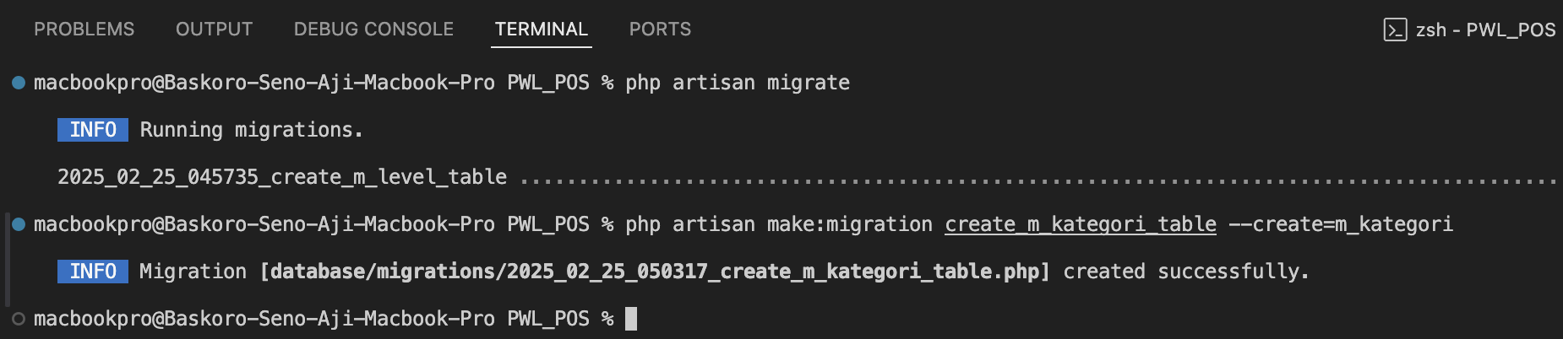

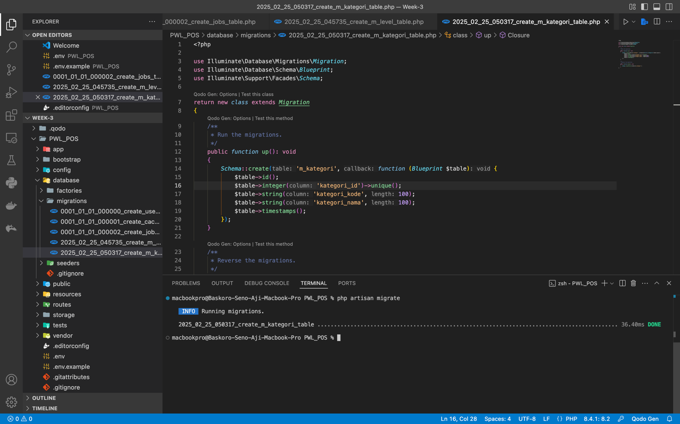

1. by implementing the same syntax sentences we’ve created the m_kategori and insert all the criteria that the table have.

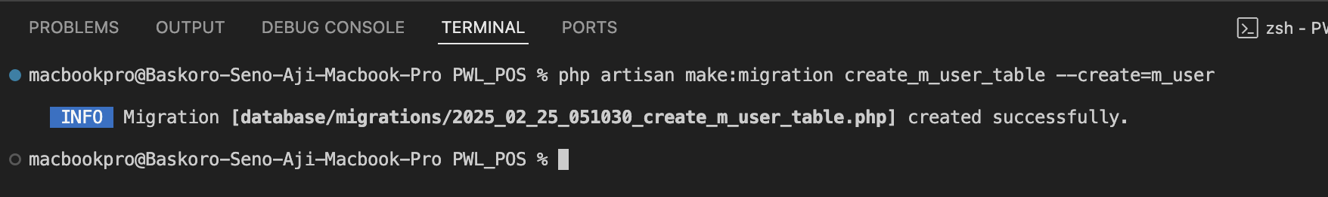**Praktikum 2.2 – Pembuatan File Migrasi Dengan Relasi**

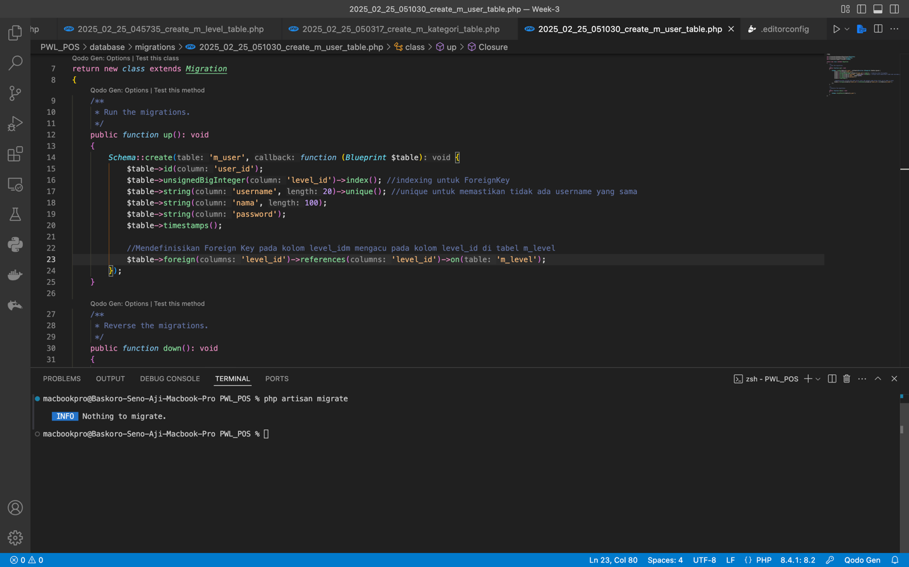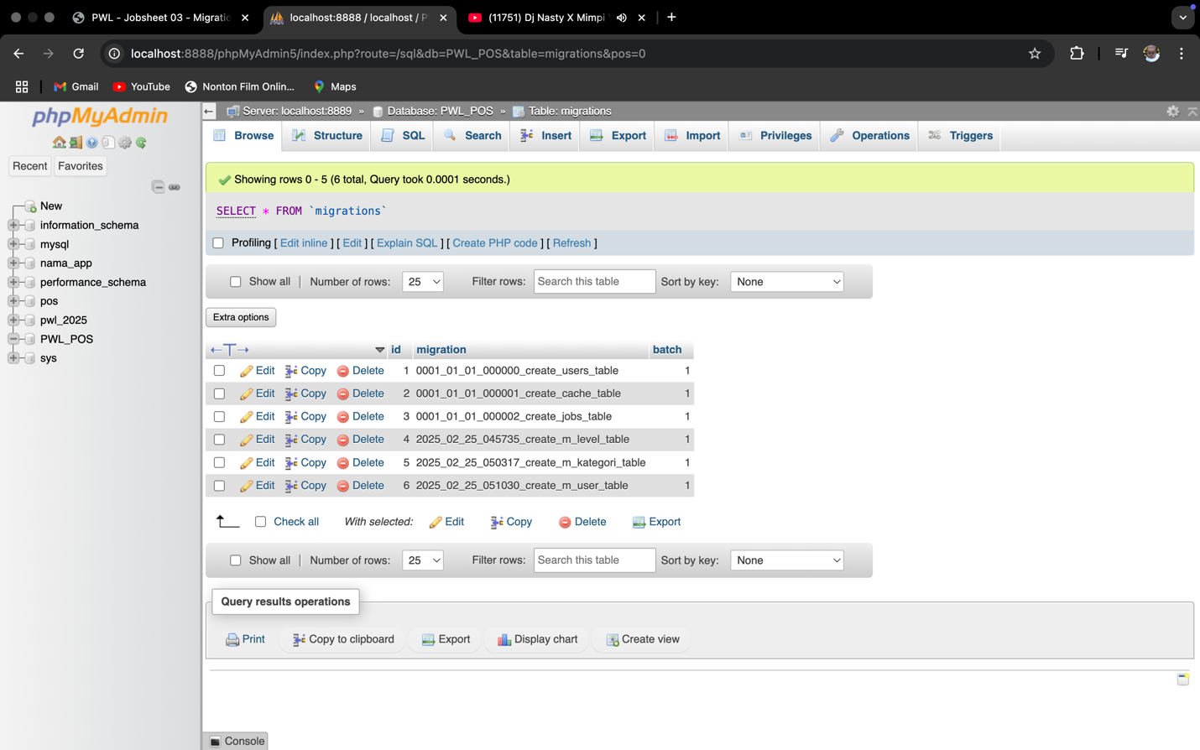

1. In this section we’re implementing the **MIGRATIONS** for the table that have the foreign key of the other table that implement the primary key and have the relations with the other table, everything is the same but things that make it different only the criteria or code that implement the foreign key

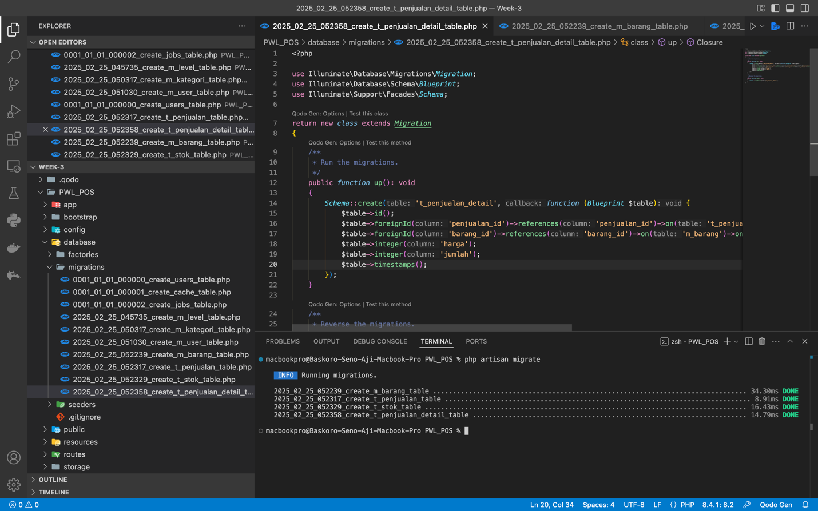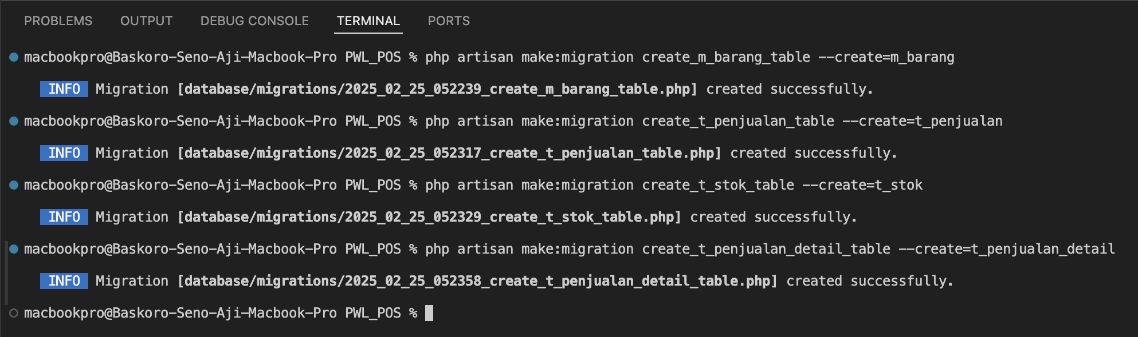4. Buat table database dengan migration untuk table-tabel yang memiliki foreign key

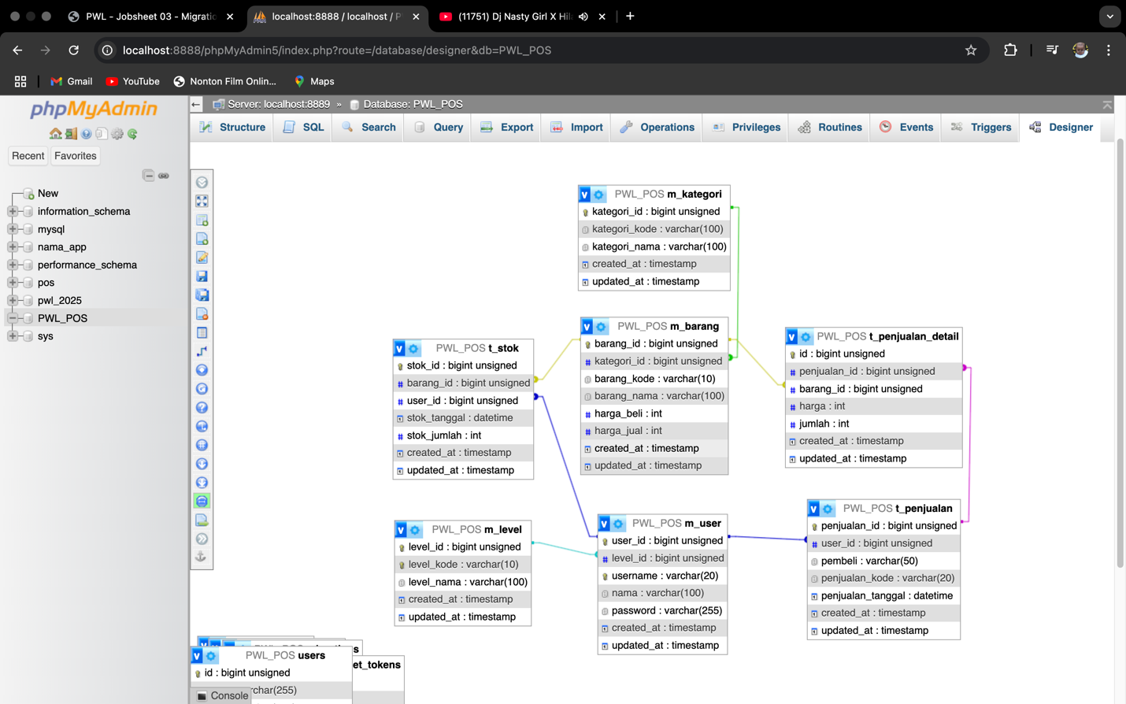

1. This part we’re doing the same but for an instance we’re also checking it on the PhpMyAdmin Designer page that every table that have the relations with the main table or table master are connected well, this designer picture have proven that we’re implementing it well.

**SEEDER**

**Praktikum 3 – Membuat File Seeder**

* Seeder on **M_LEVEL**

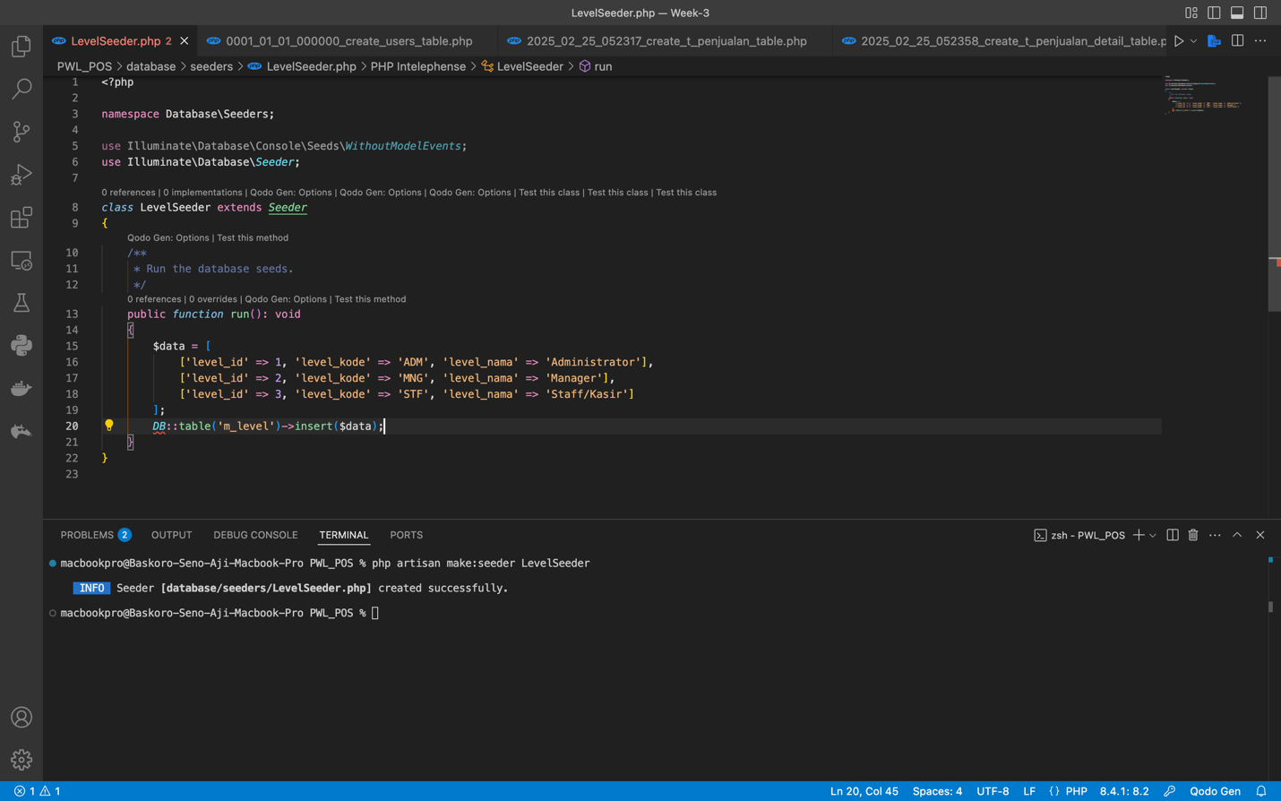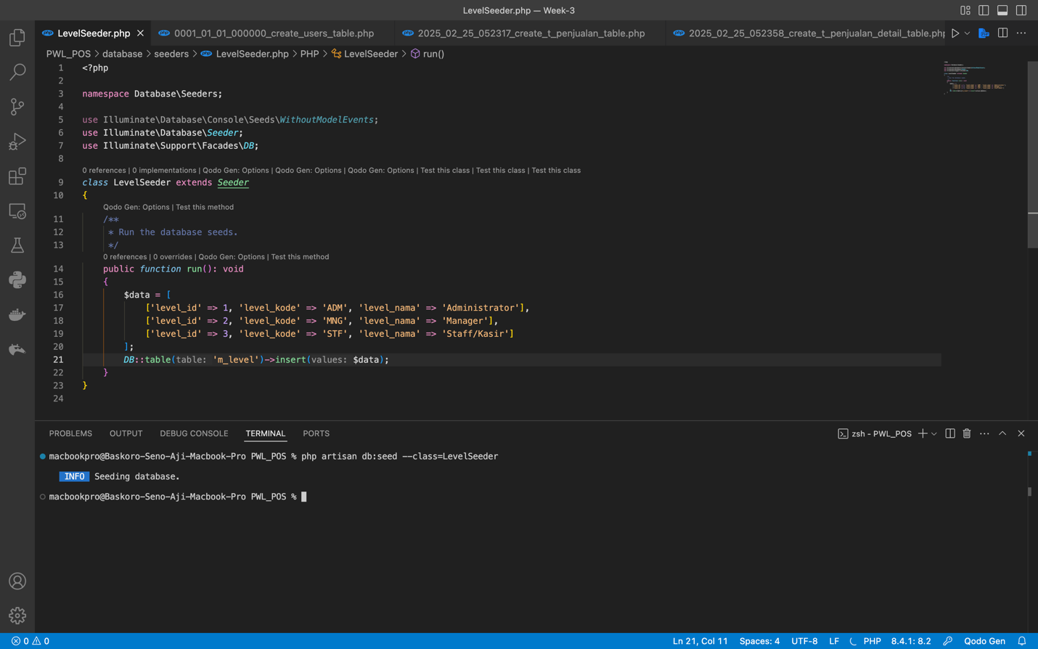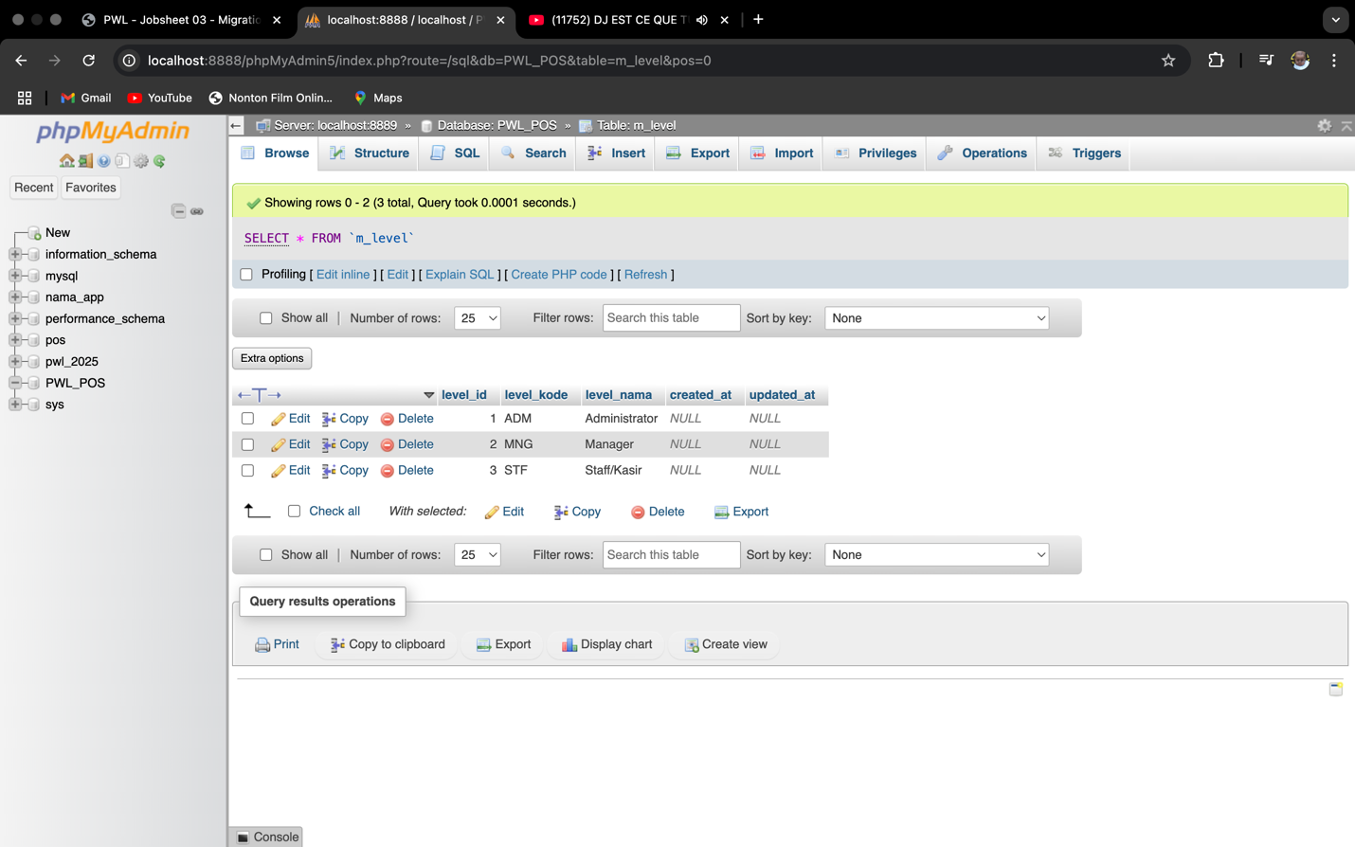

1. In this section we’re implementing **SEEDER** feature to inserting the data of every table. in this particular section we insert the data for the m_level by adding into three type of user, to add an use the seeder we’re using particular syntaxes that are :

- php artisan make:seeder <nama-class-seeder> (create seeder)

- php artisan db:seed –class=<nama-class-seeder> (to send the seeder data to the database)

* Seeder on **M_USER**

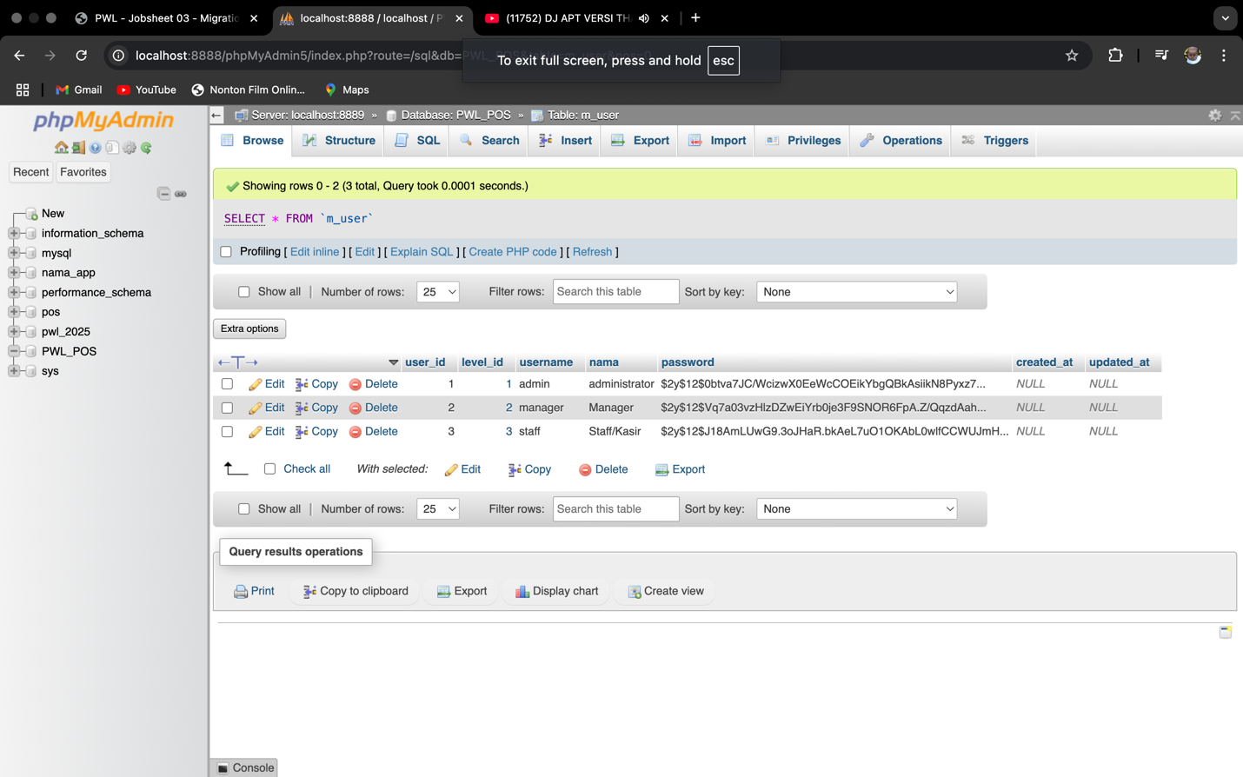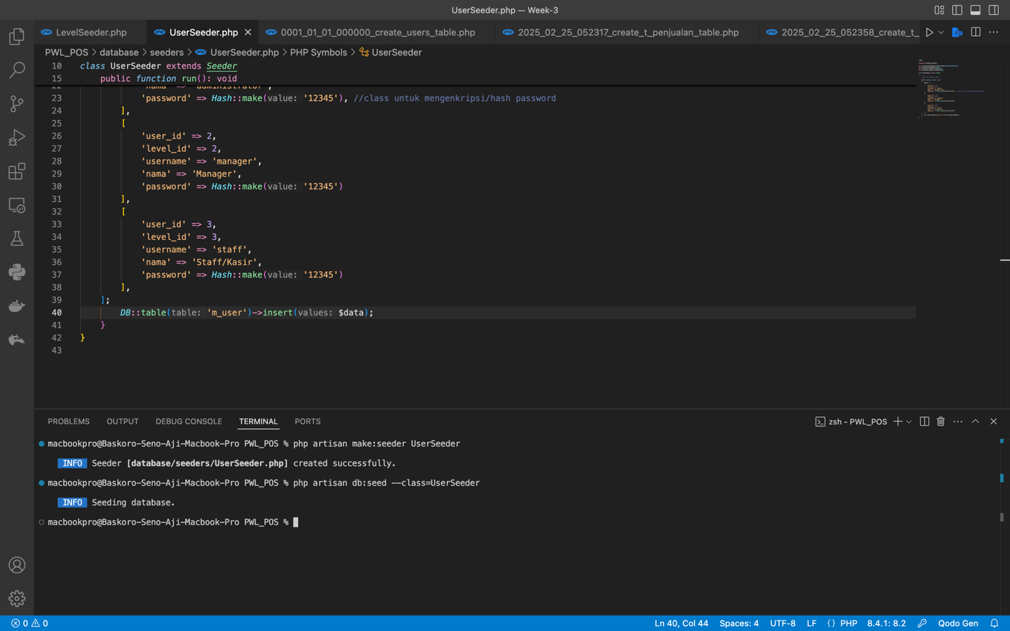

1. Implementing the same syntaxes to create the user by referring to the equivalent category to be insert on the databases

10. Sekarang coba kalian masukkan data seeder untuk table yang lain, dengan ketentuan seperti berikut

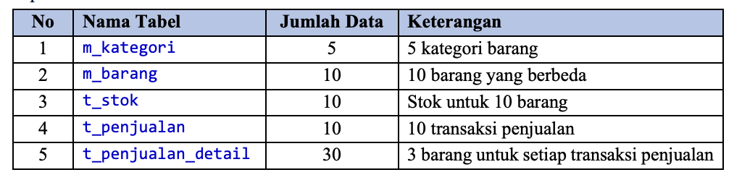

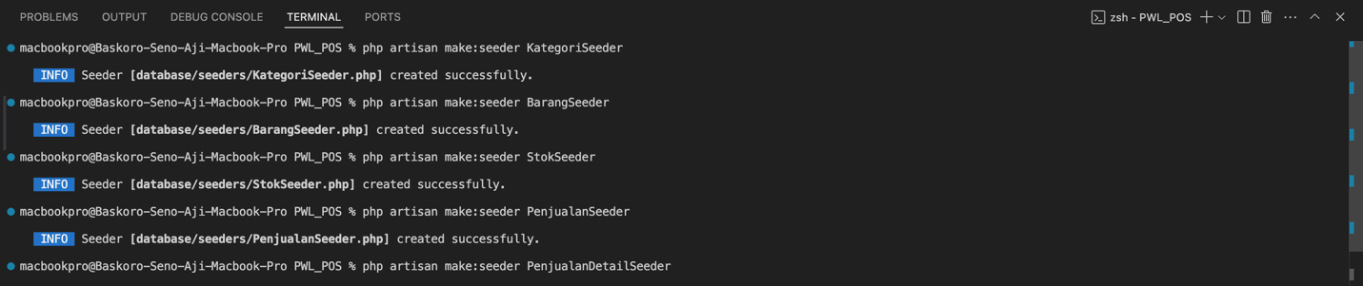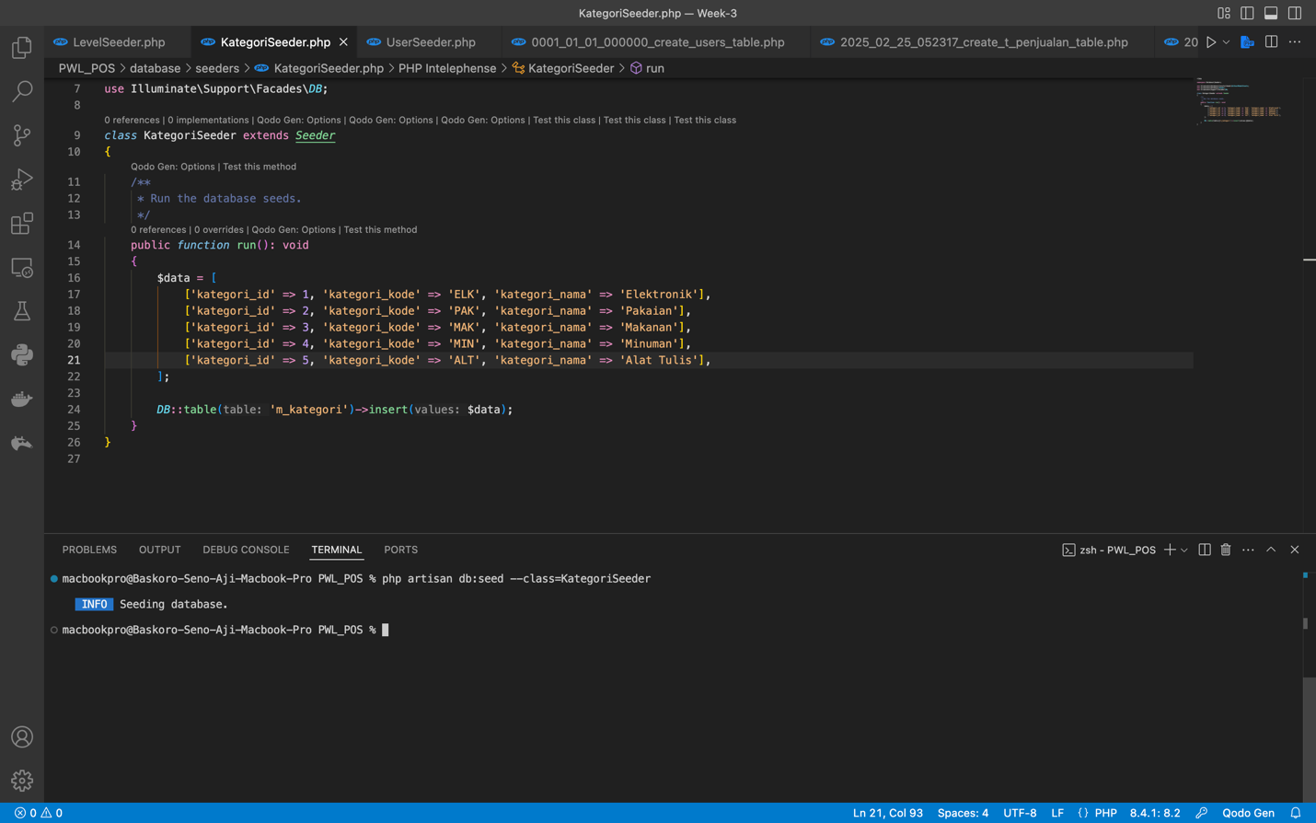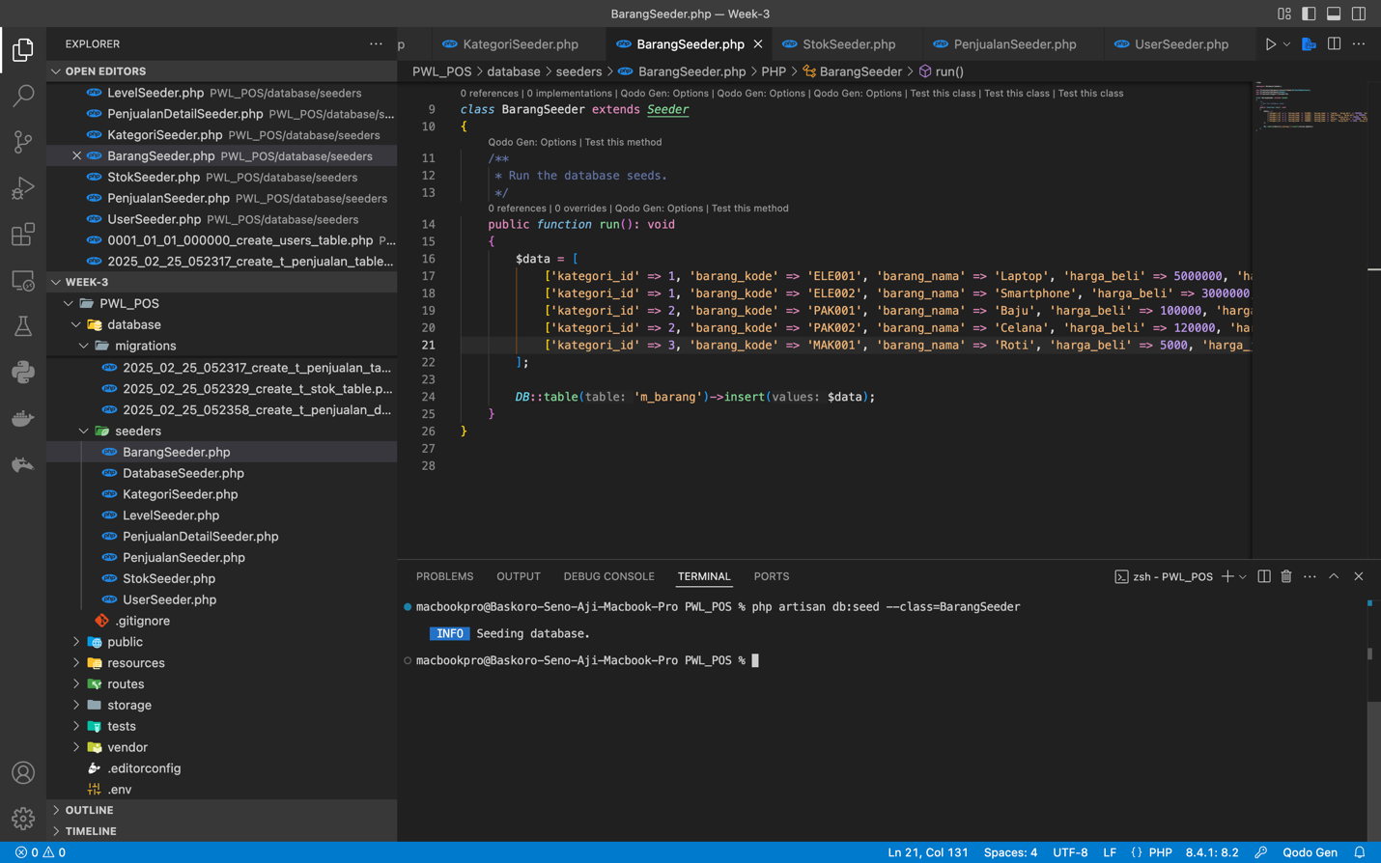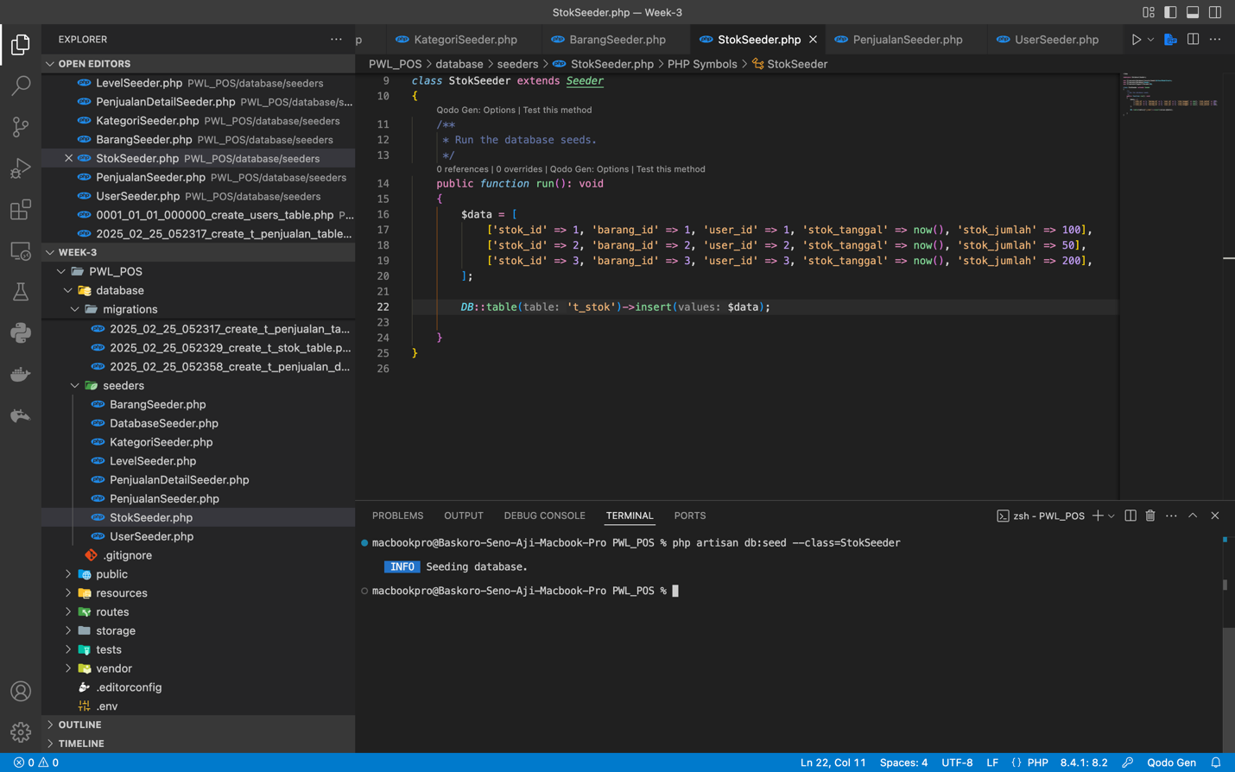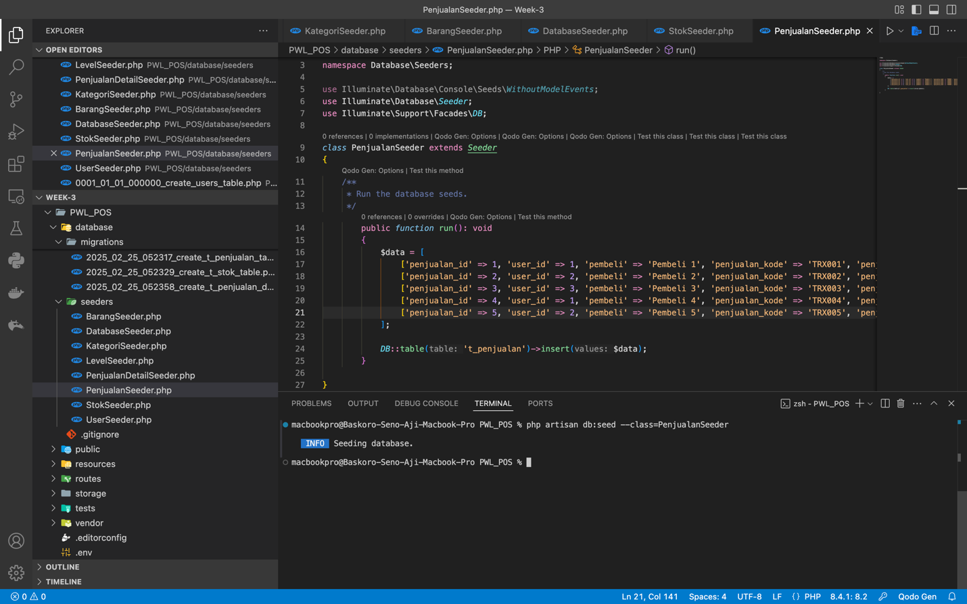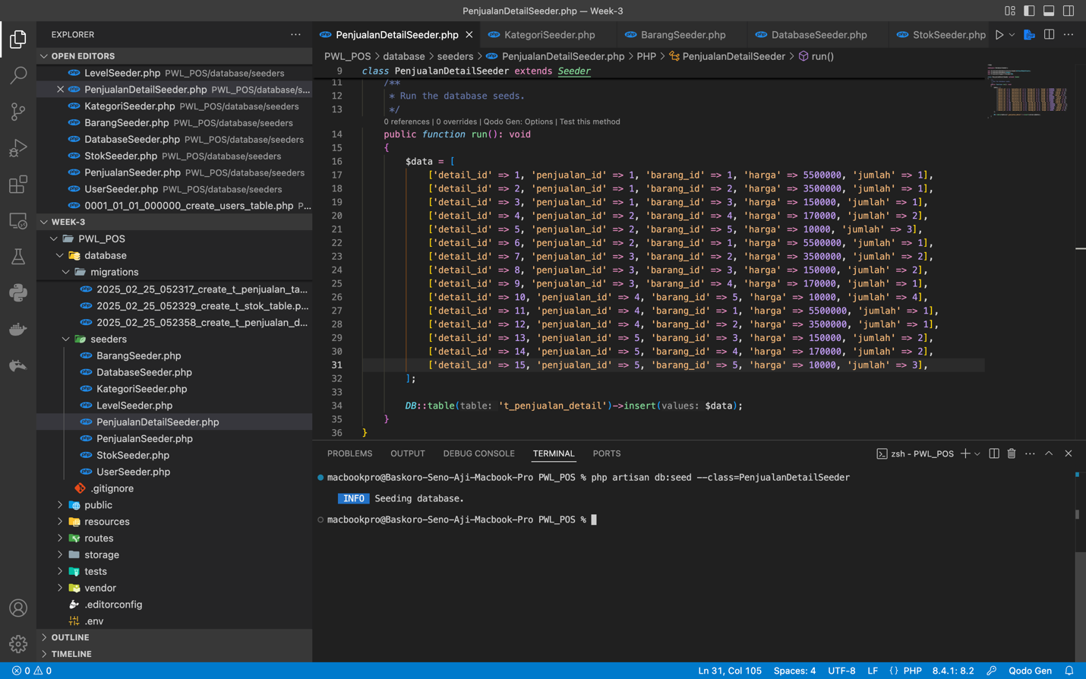

1. This section task we need to implement the fill the data or do the seeder with the criteria above, in this section I’ve manage to do it all by implement or fill it in every column sections so It could be detect by the database

**DB FAÇADE**

DB Façade is a feature that use the query using RAW QUERY or code the full SQL syntax, there are several type of DB Façade that use in this practicum, that are :

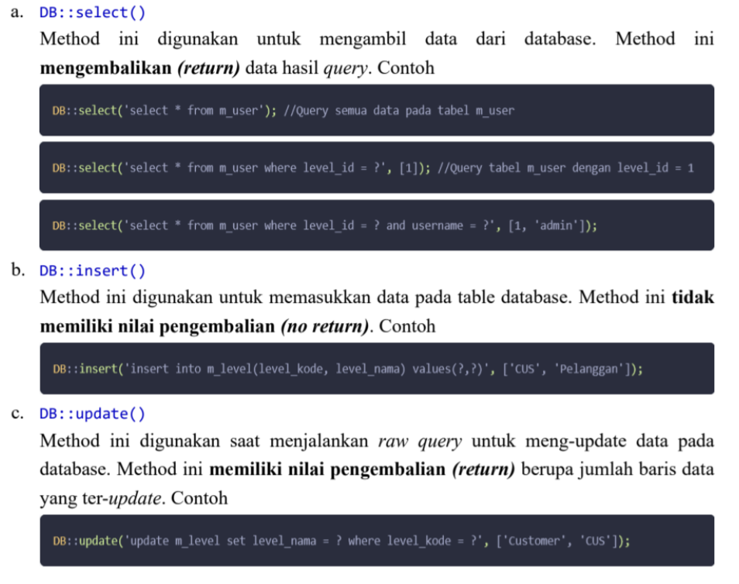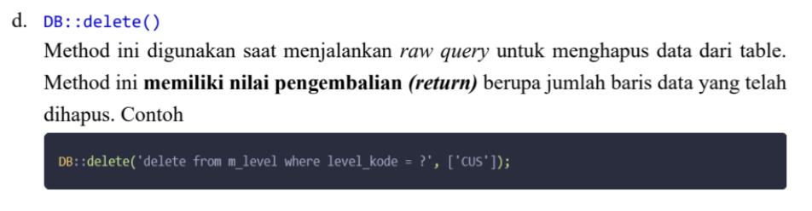

**Practicum 4 - Implementasi DB Façade**

* DB Façade Insert :

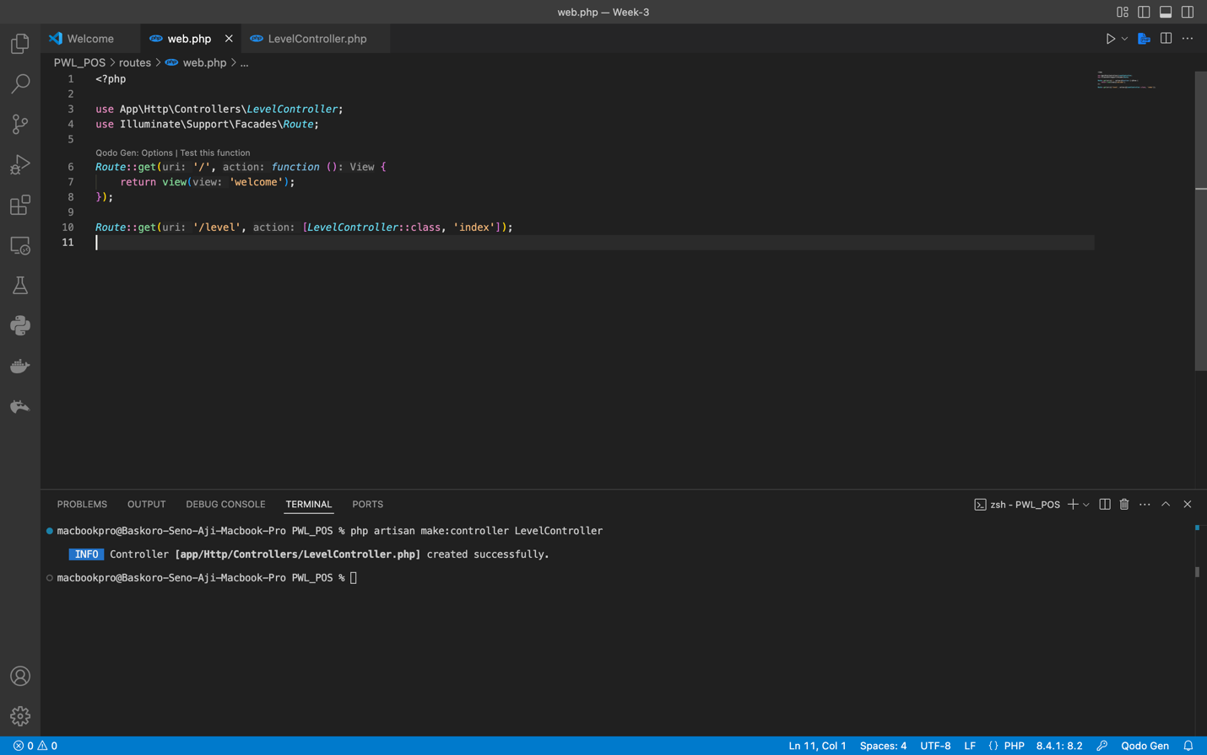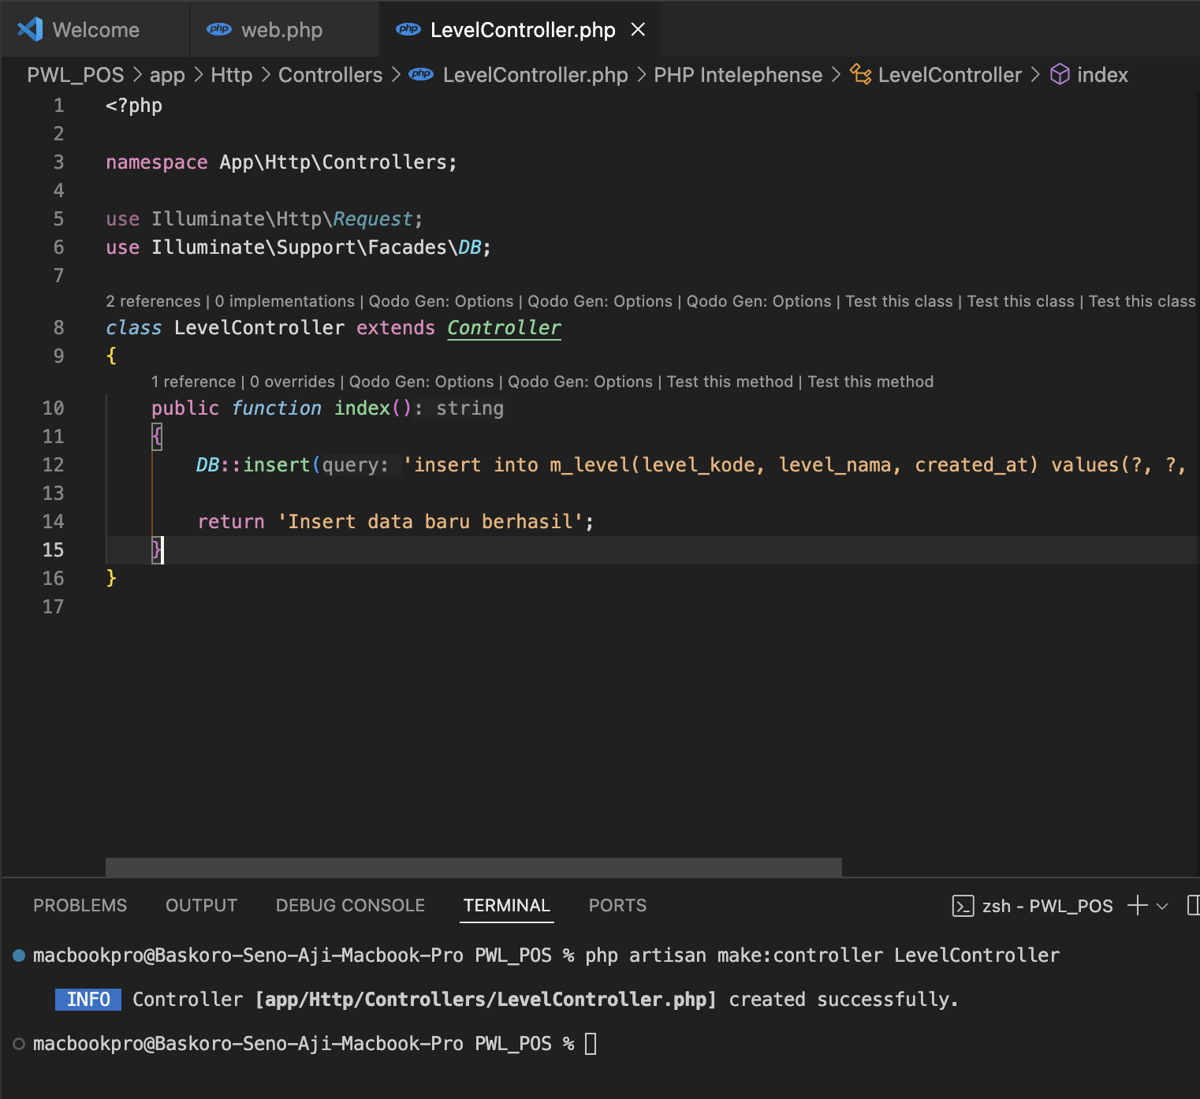

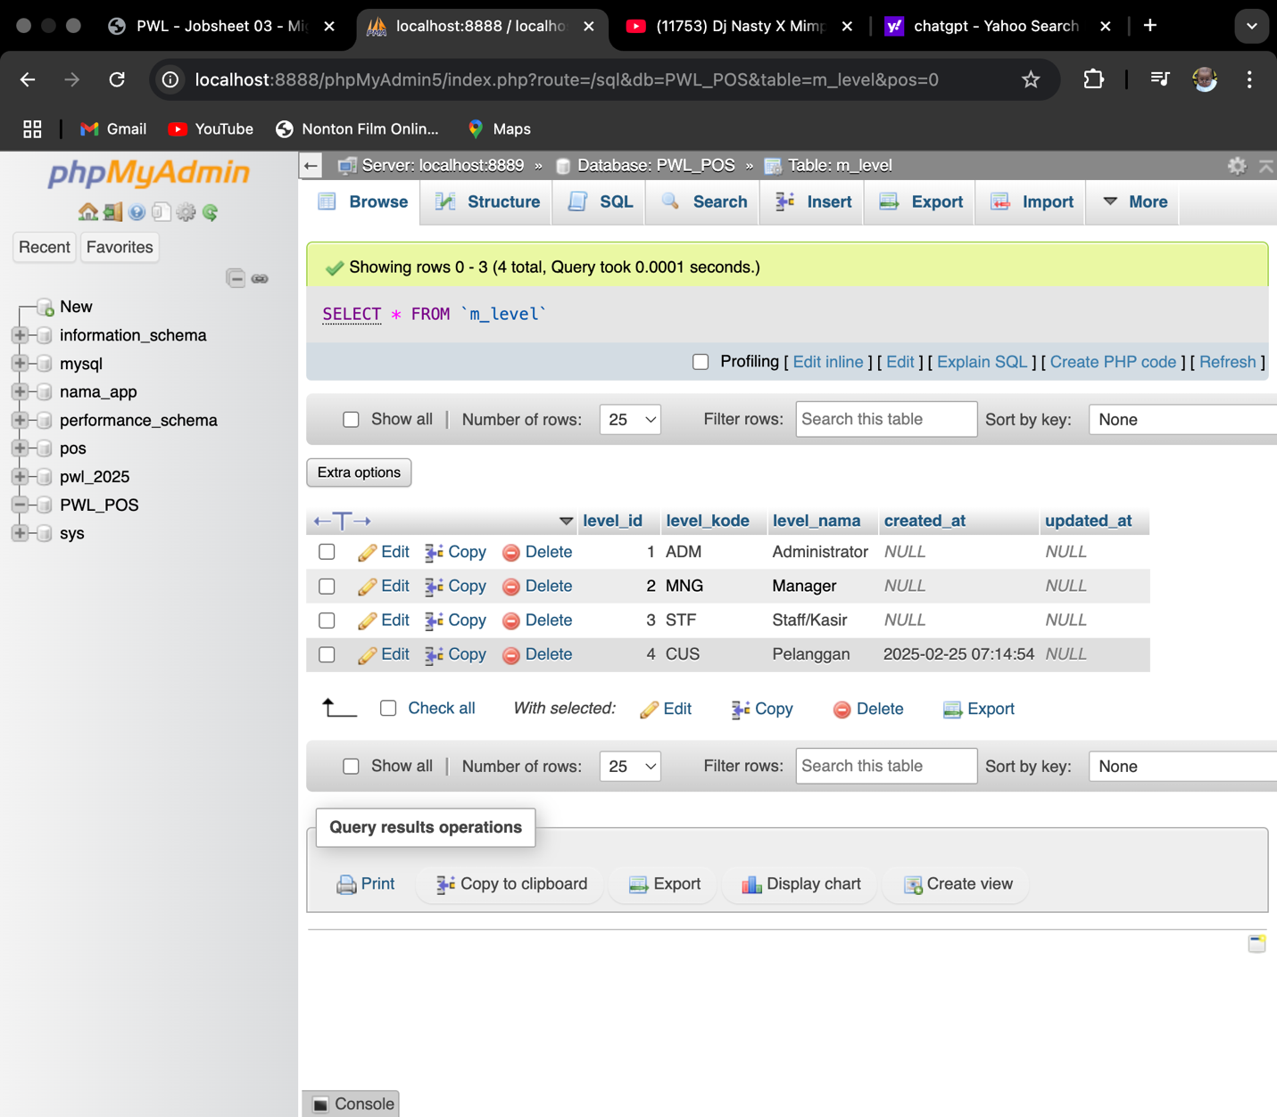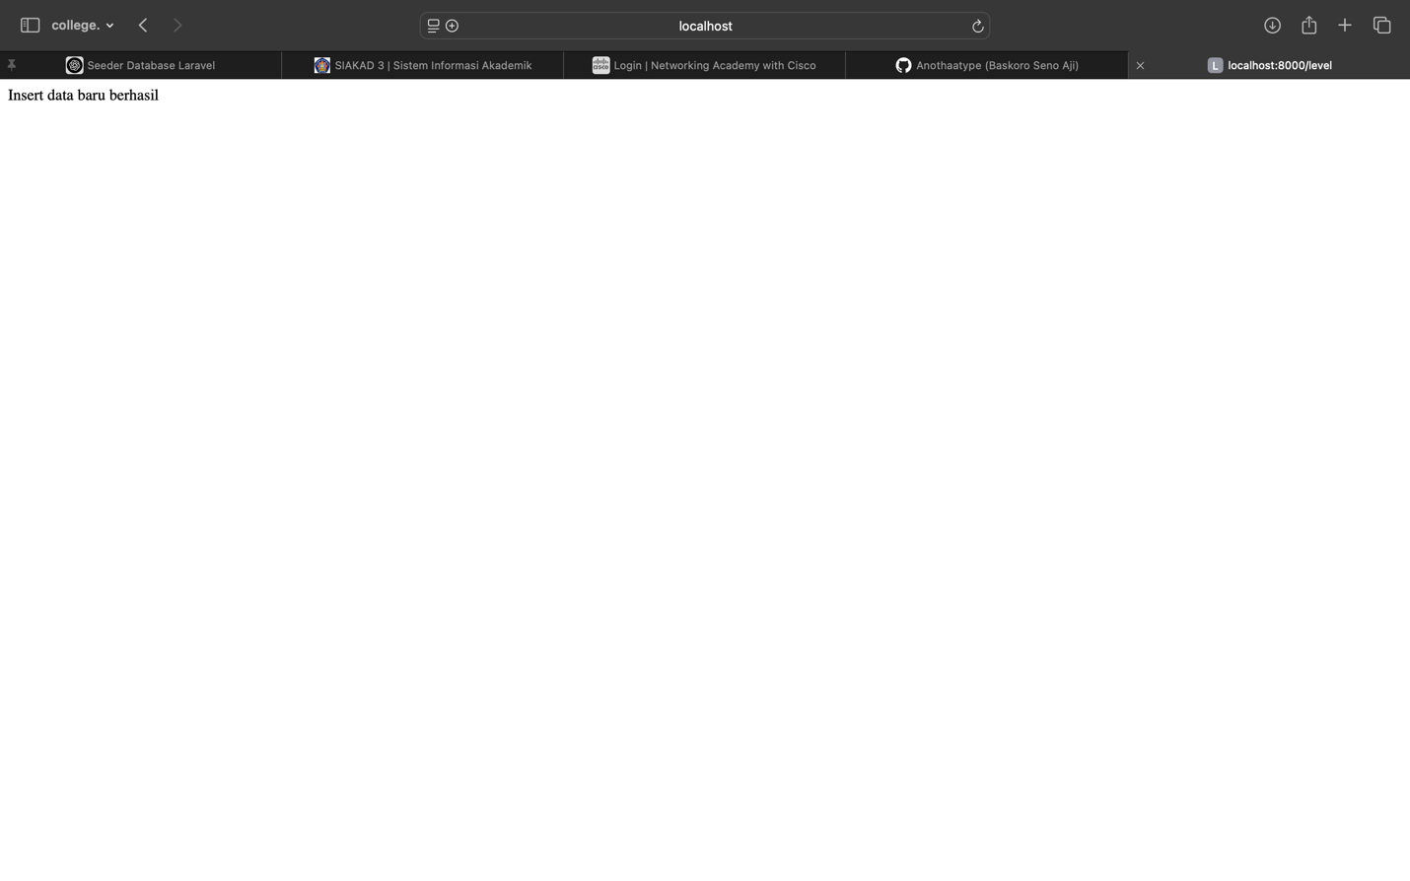

1. In this section we do some several steps to implement the DB Façade statement, first we need to create the controller by implementing php artisan make:controller (NameController) where in this section are focusing for the M_LEVEL table, second we need to set and connect the route to the controller. Third we need to insert the data to the level controller. Fourth we need to test and launch it in the web by accessing the /level on localhost, then we can see the output of the inserting data also the changes that occur in the PhpMyAdmin

* 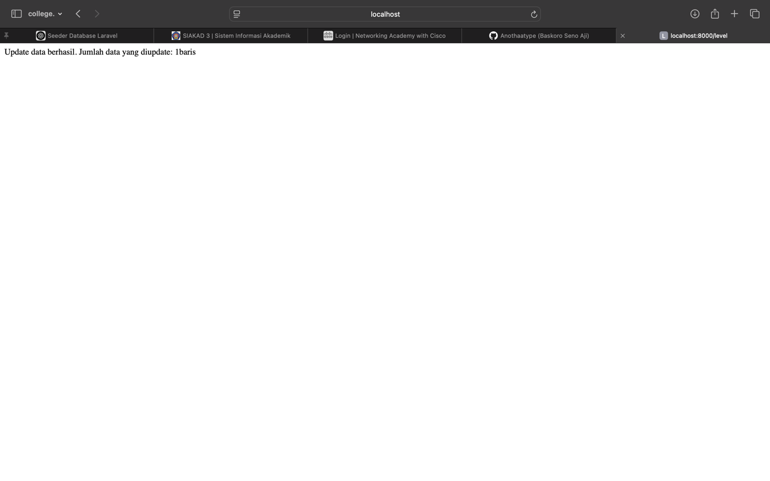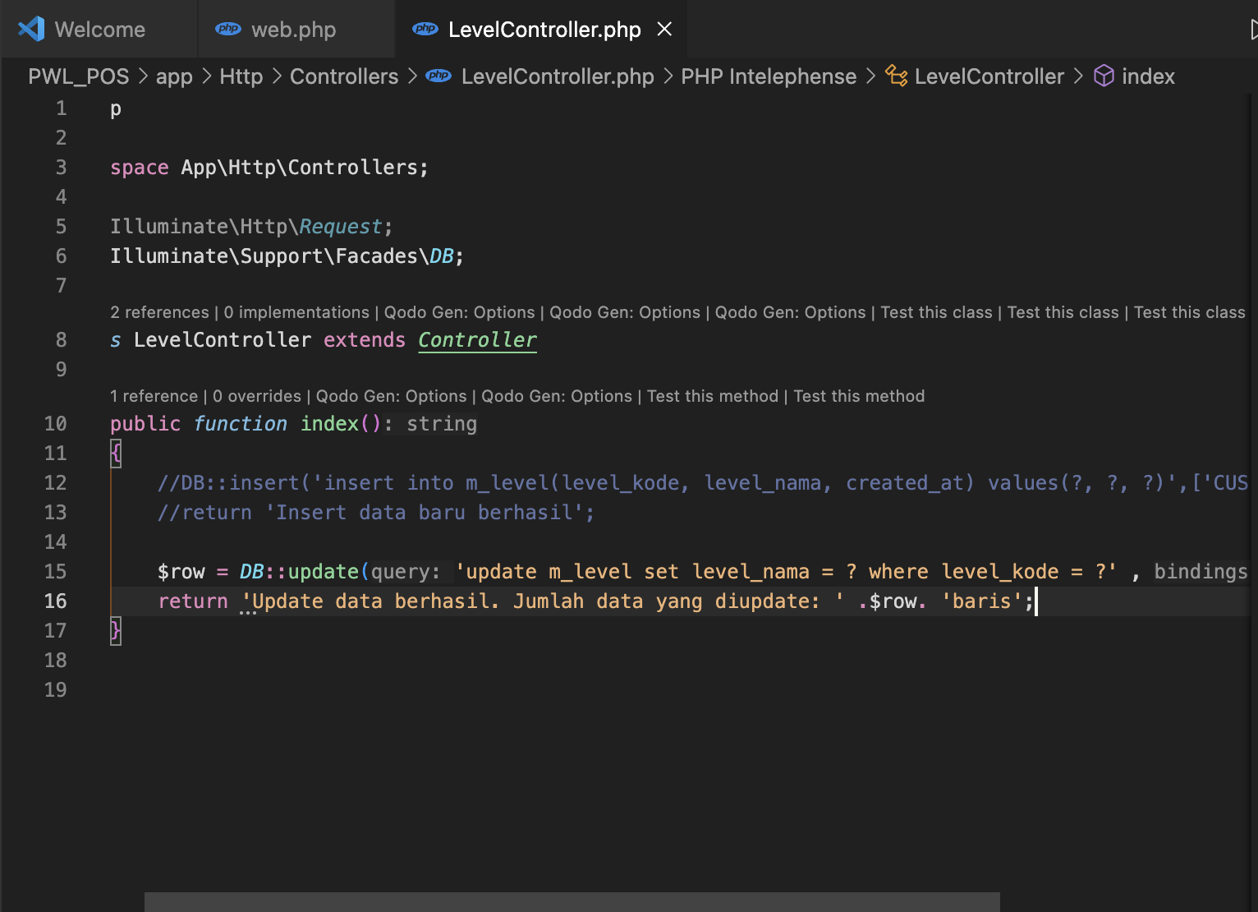DB Façade Update

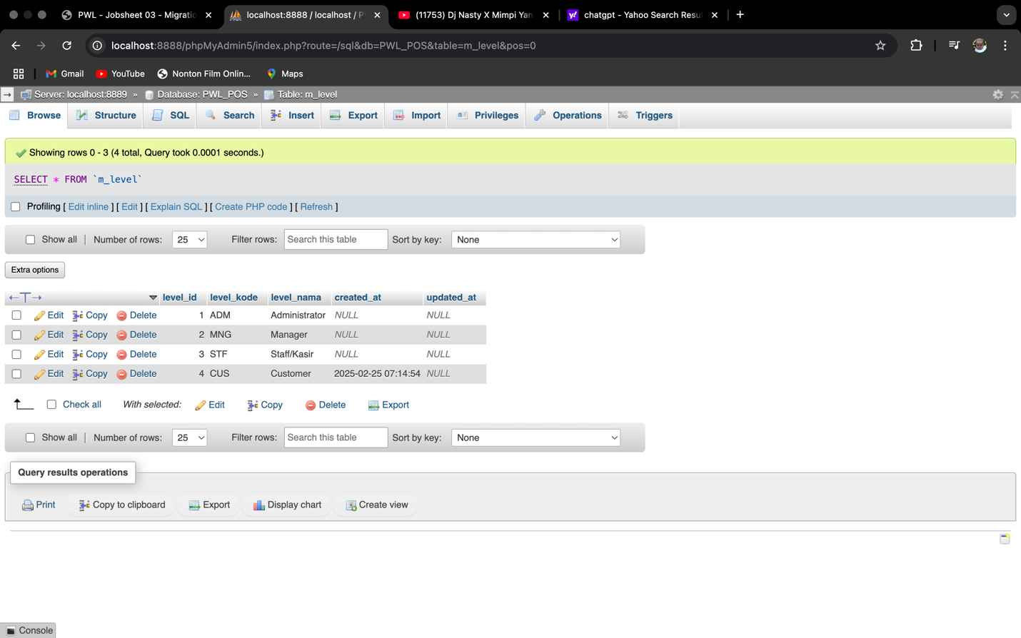

1. In this section we’re implementing the DB Façade for updating the data inside the table where we add CUS in the new row

* 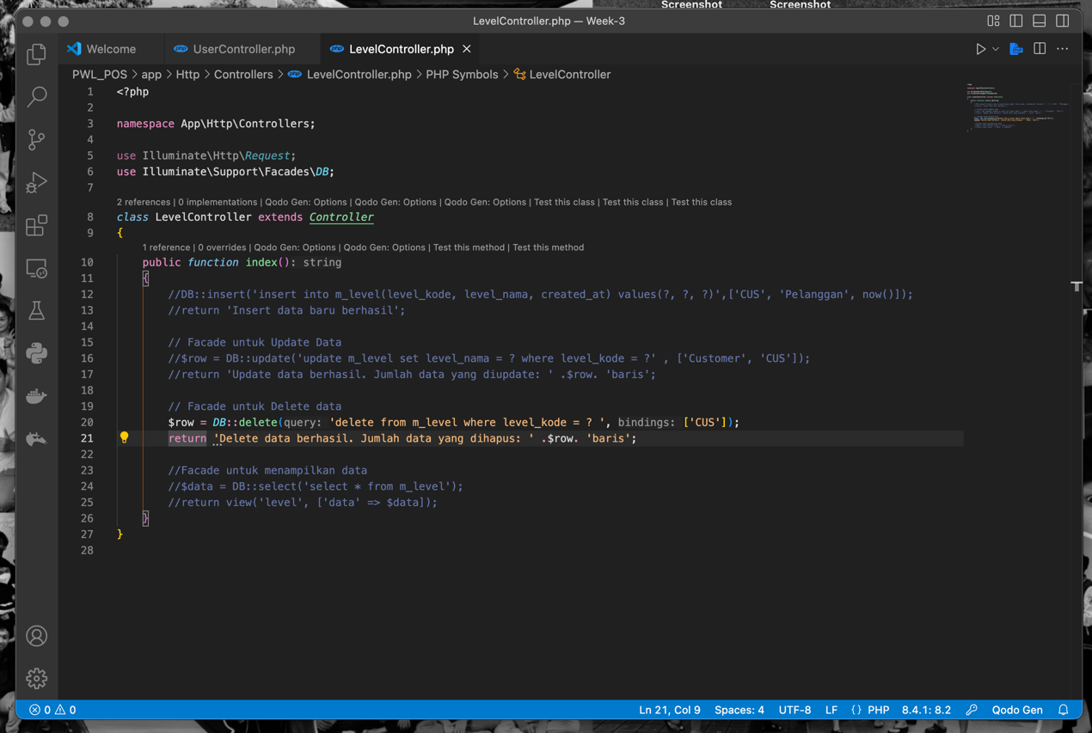DB Façade Delete

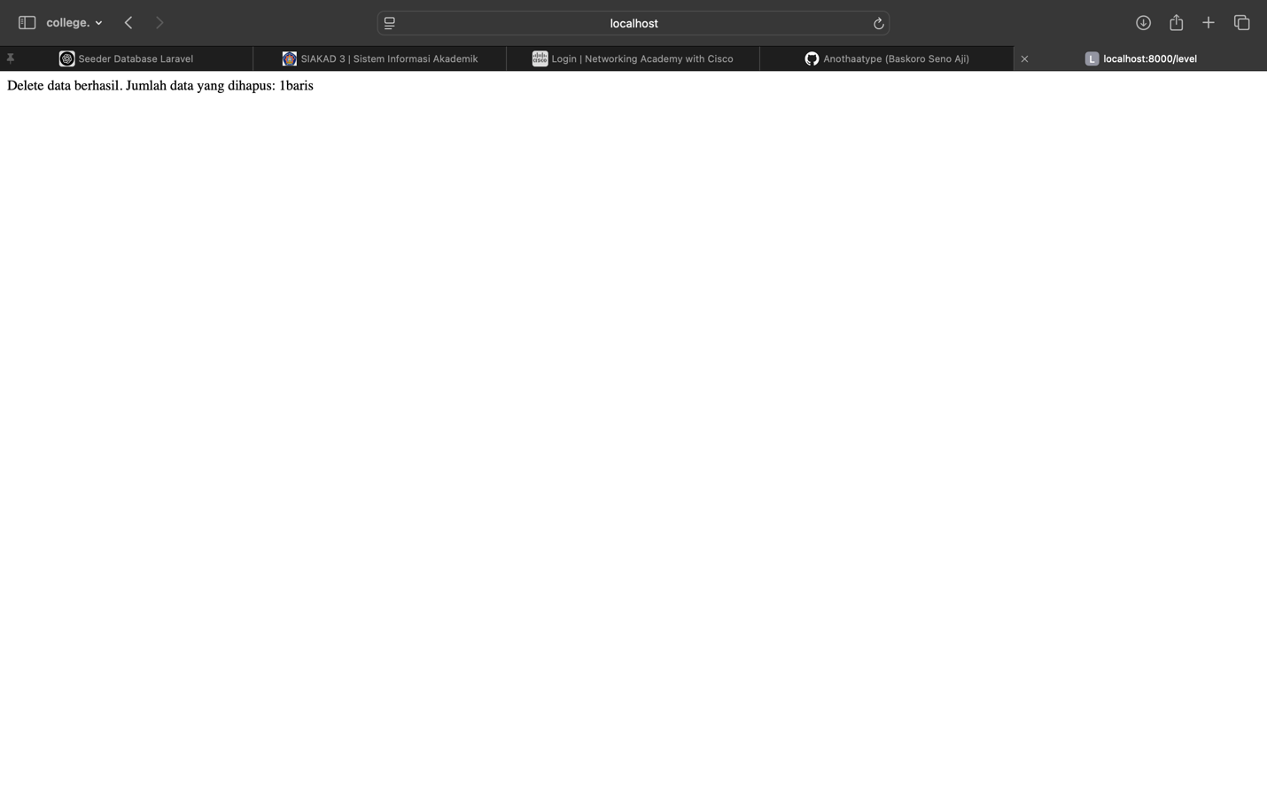

1. In this section we try to implement the delete db façade by deleting the data that we’ve update in db faced update

* DB Façade Select

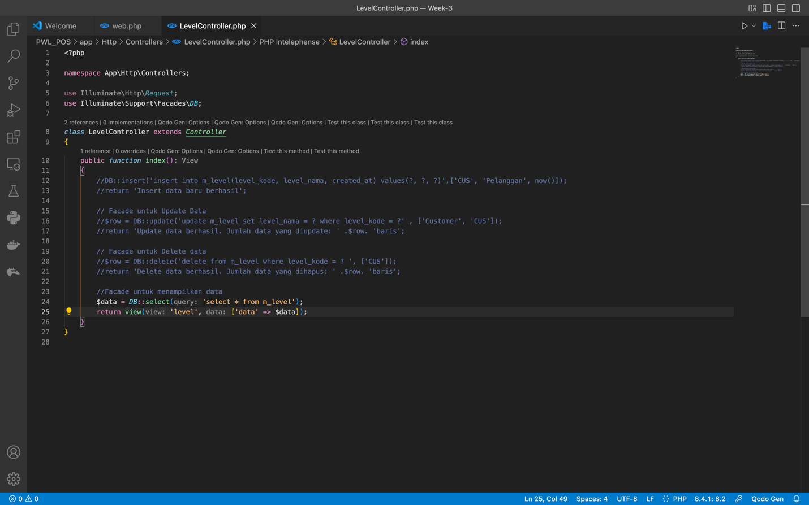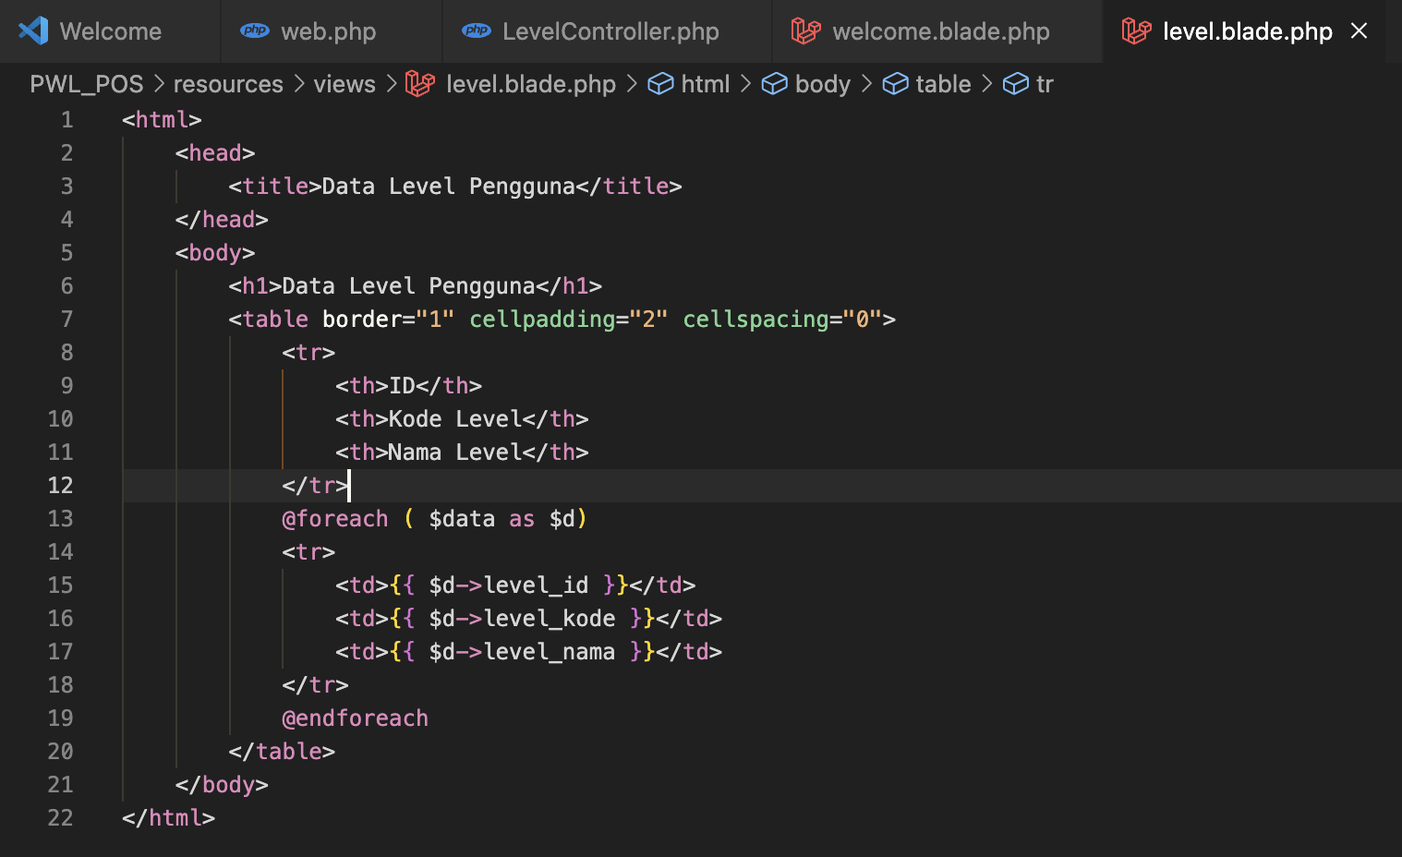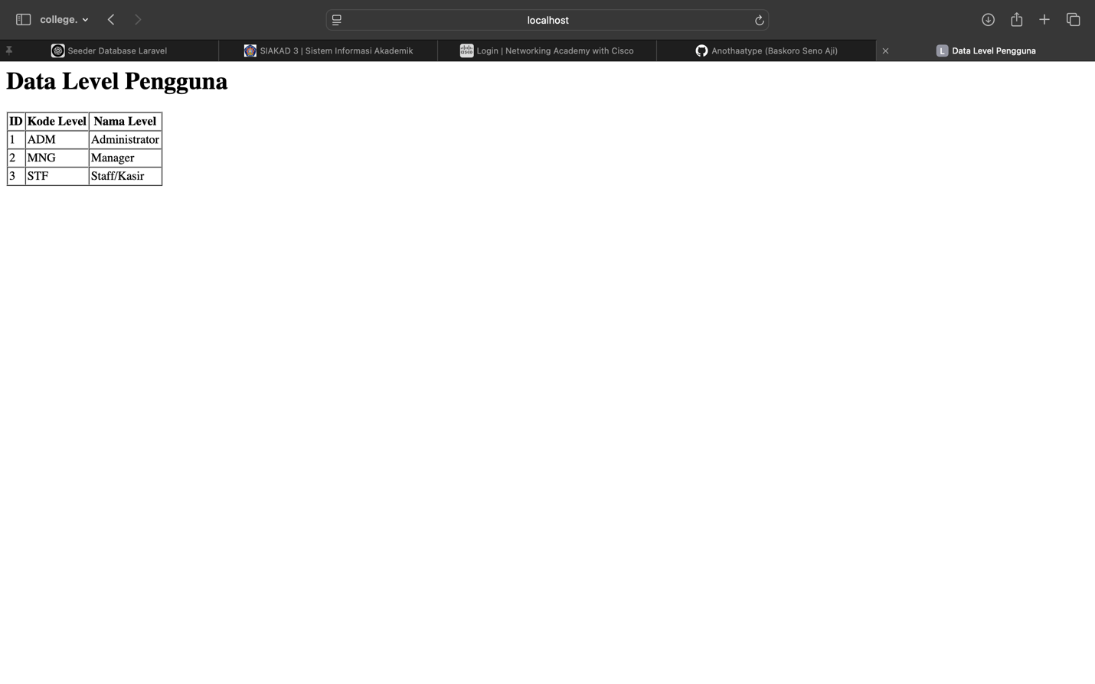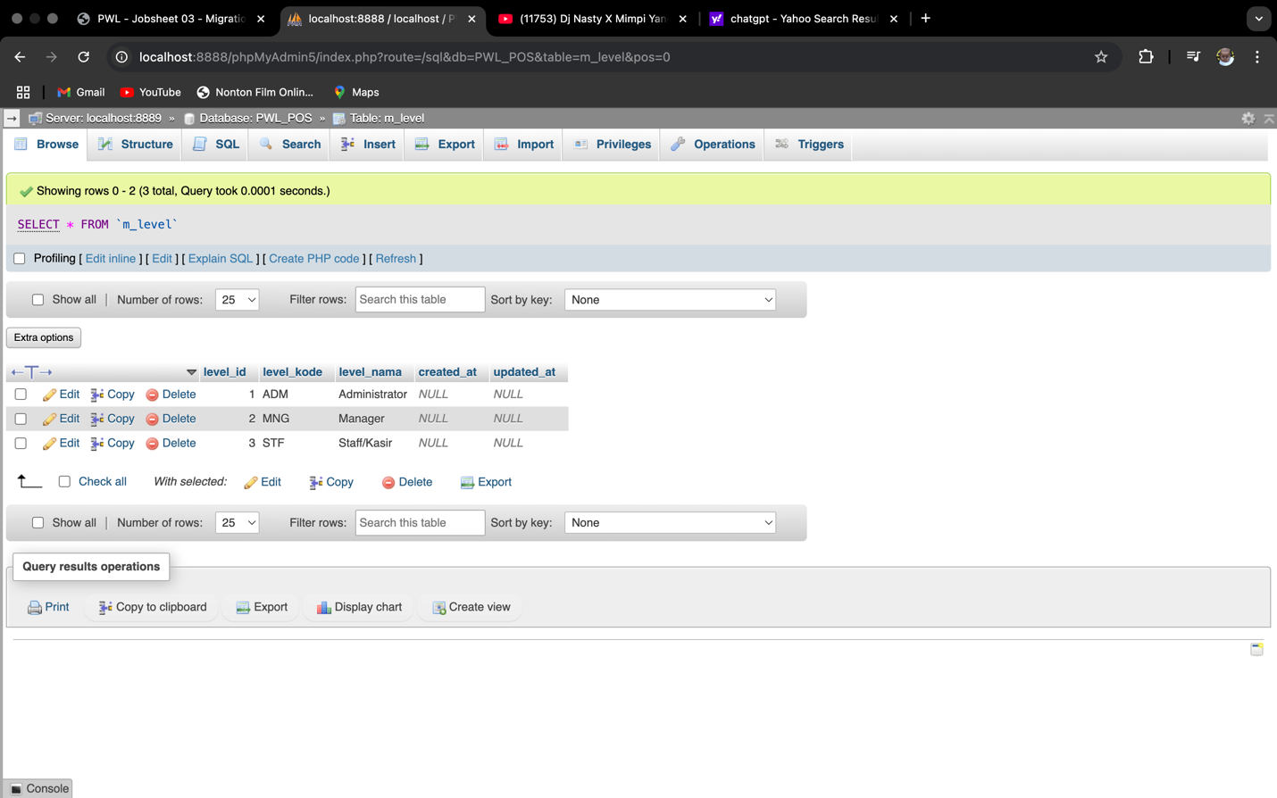

1. In this section we try to show or select all the data in the m_level table by creating the html page or view in the Laravel, this section manage a new step where we need to connect the blade.php into the controller and route.

**Query Builder**

Query Builder is a feature provided by Laravel for performing CRUD (Create, Retrieve/Read, Update, Delete) operations on a database. Unlike raw queries in DB Facade, which require us to write SQL commands manually, Query Builder allows access to these SQL commands through methods. This means that instead of writing SQL commands directly, we only need to call the available methods in Query Builder.

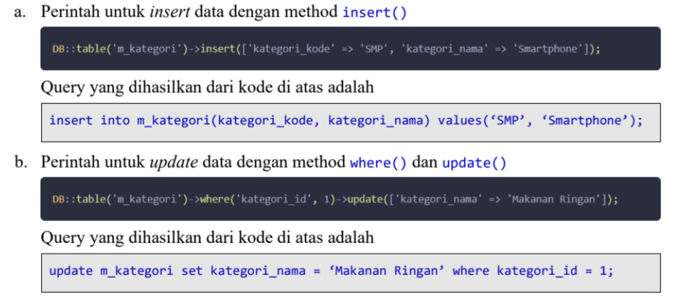

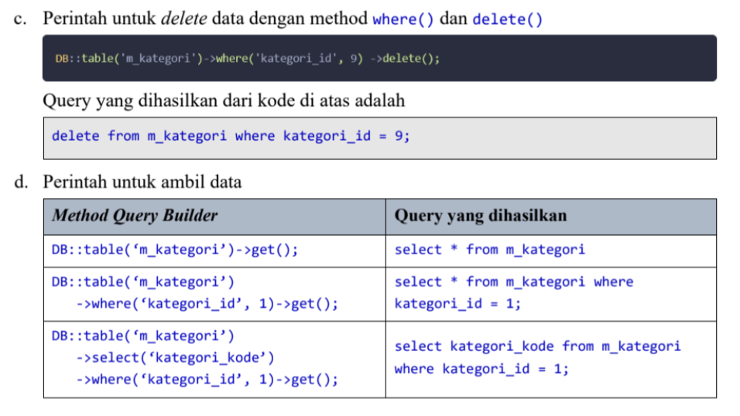

**Praktikum 5 – Implementasi Query Builder**

* Query Builder Insert

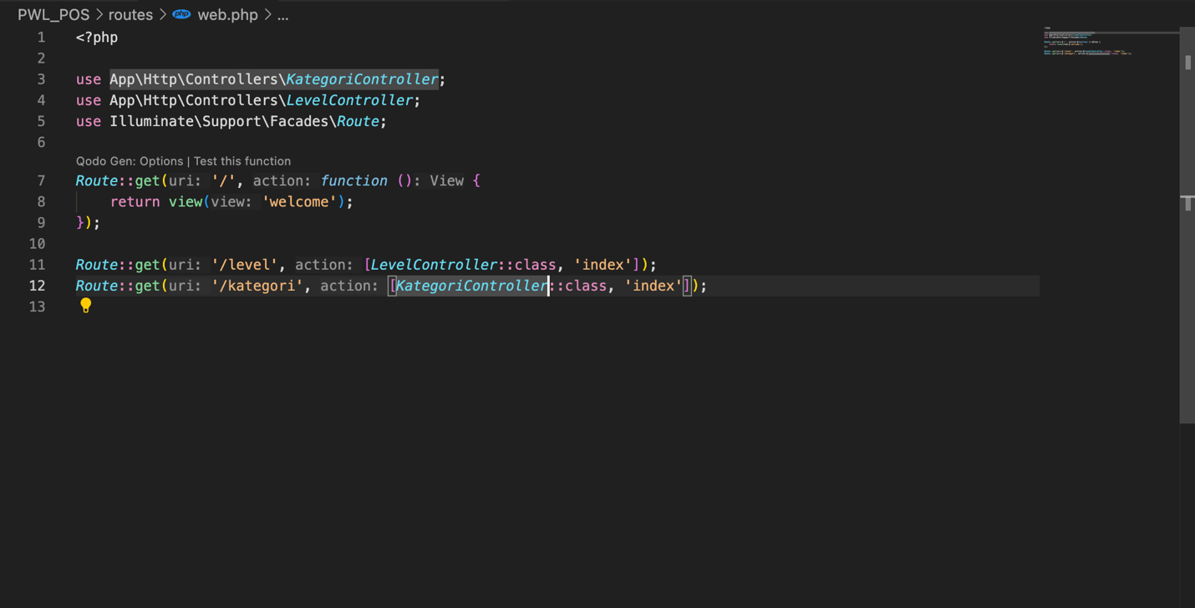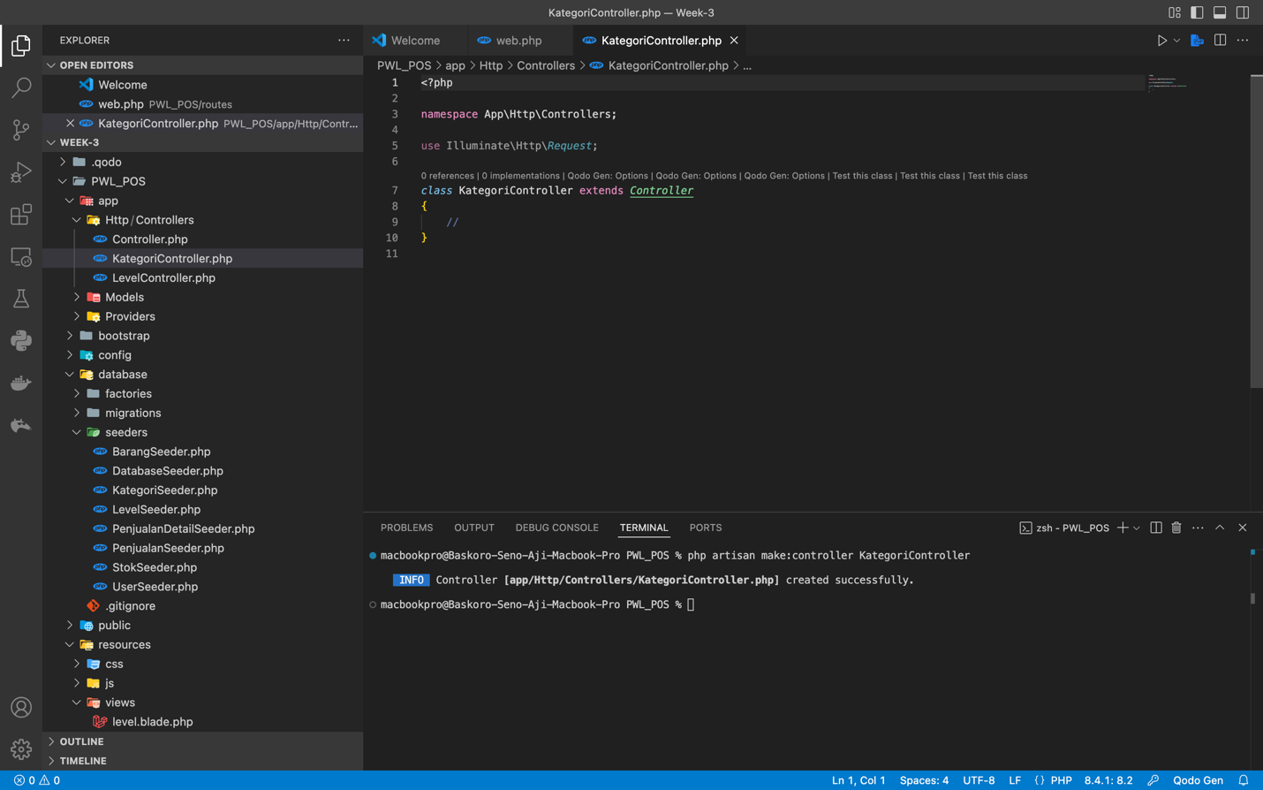

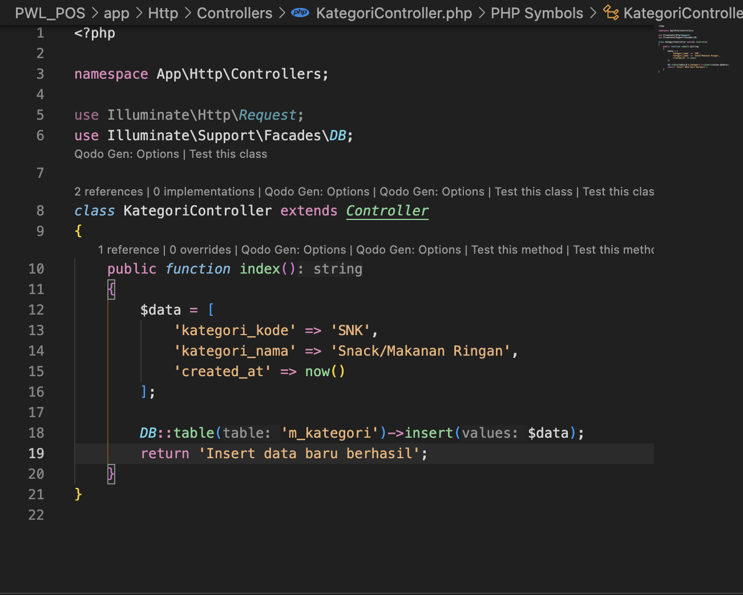

1. in this terms we insert all the data in the $data variable but to call or use it we use the index function where the already connect the route into the KategoriController so in that terms when we use /kategori we can see the output of the return where it is “Insert data baru berhasil”

* Query Builder Update

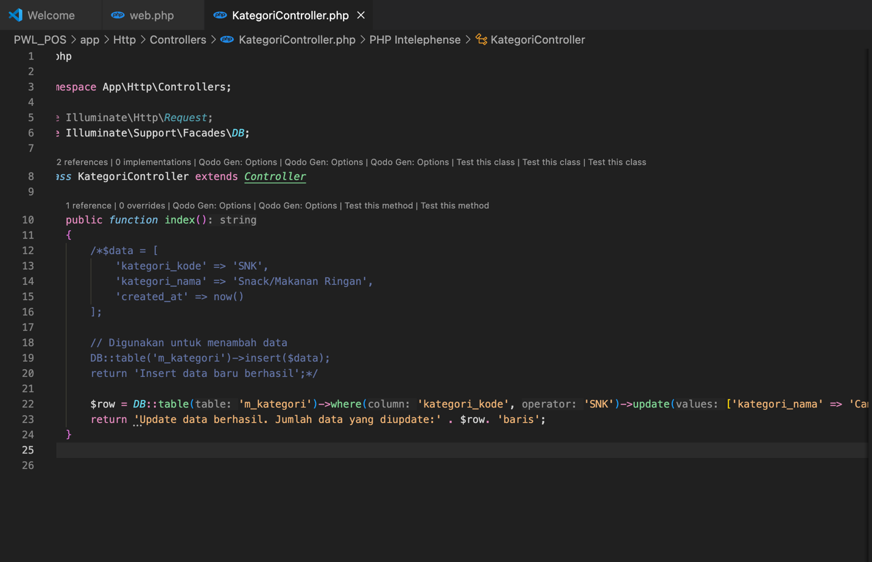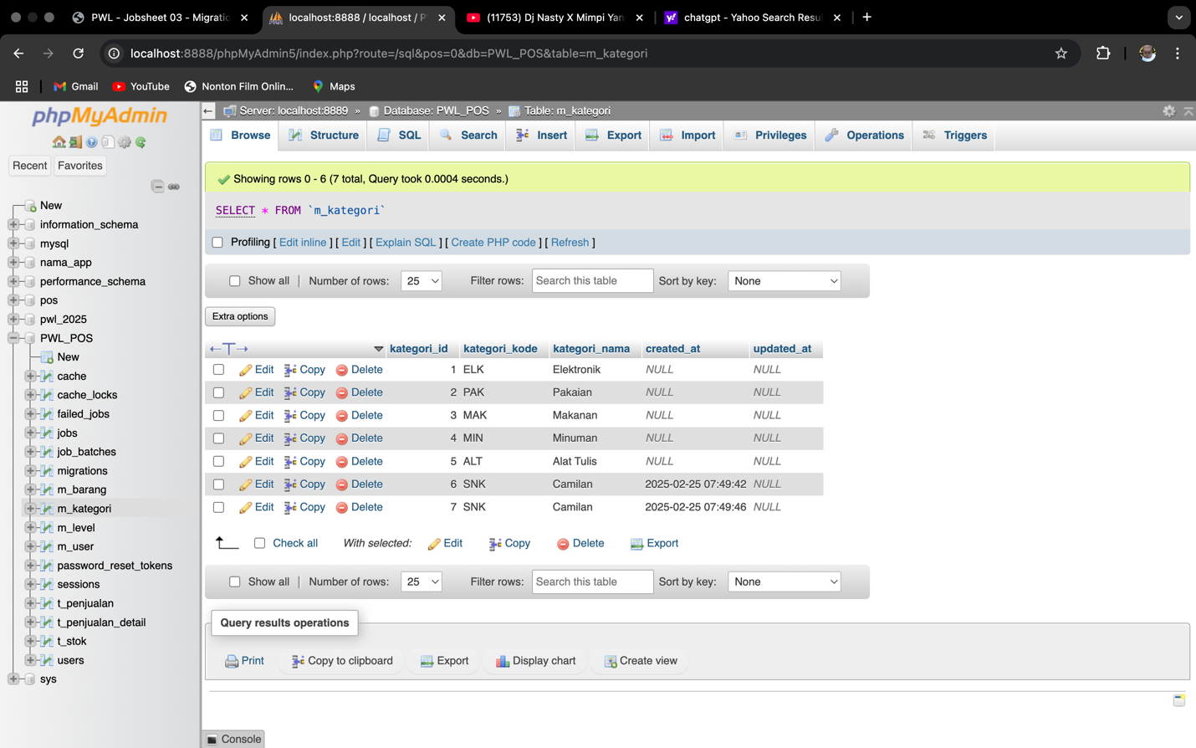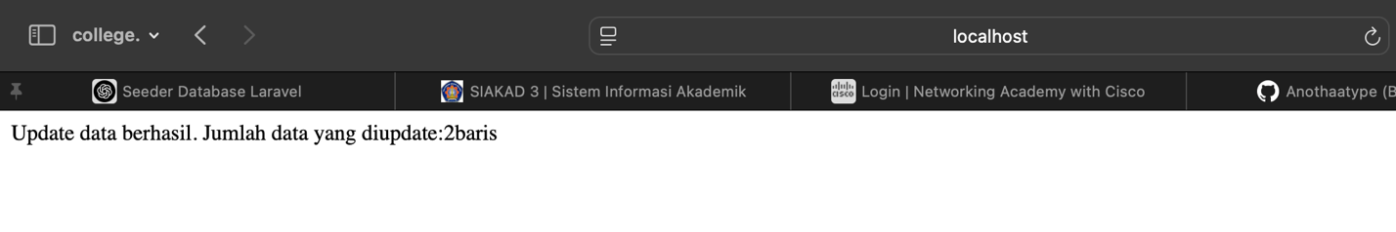

1. In this section we’re implementing the update terms for the Query Builder where we can see that the output are updating 2 row, we add the camilan 2 times.

* 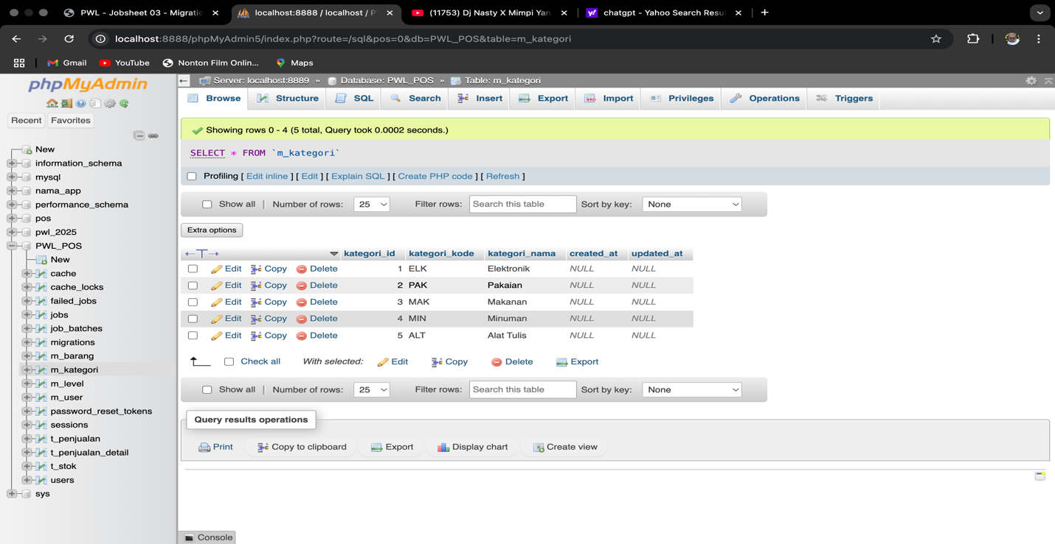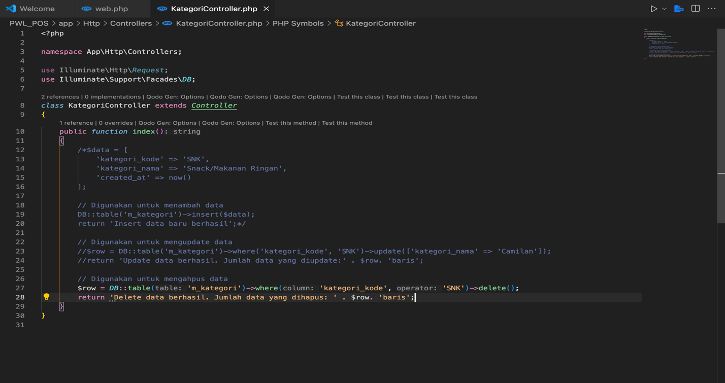Query Builder Delete

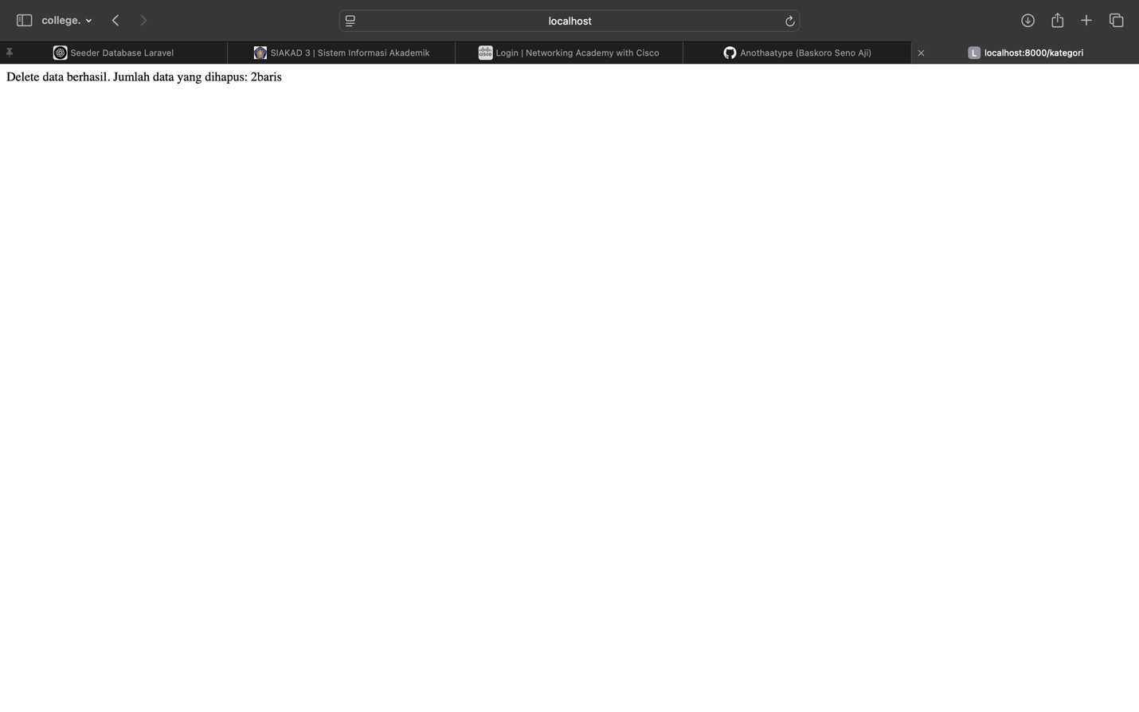

1. In this section we can see clear that we’re implementing the delete feature, we look that the output has erased the 2 camilan rows.

* 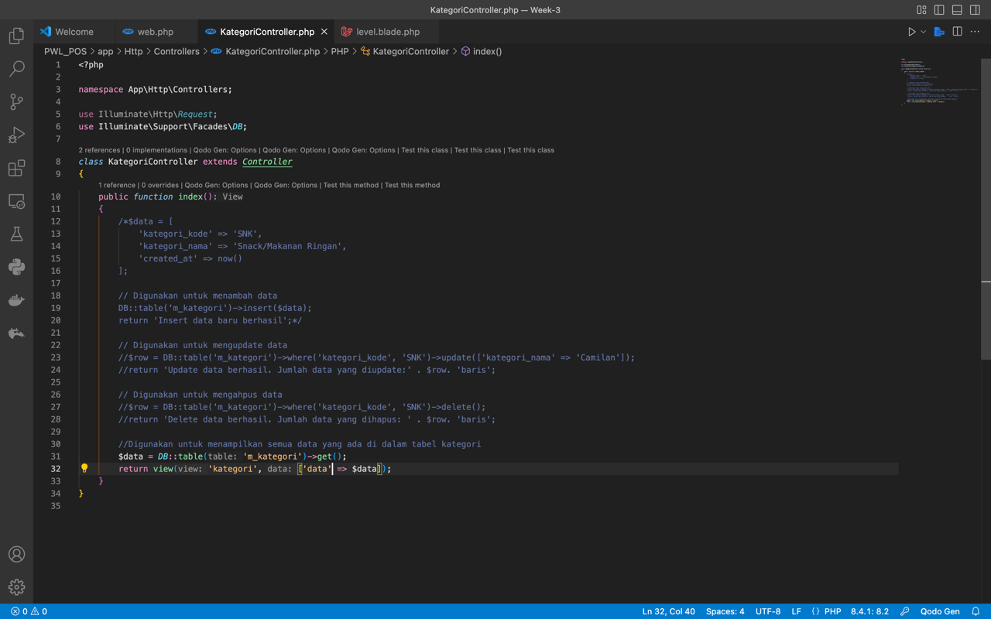Query Builder Select

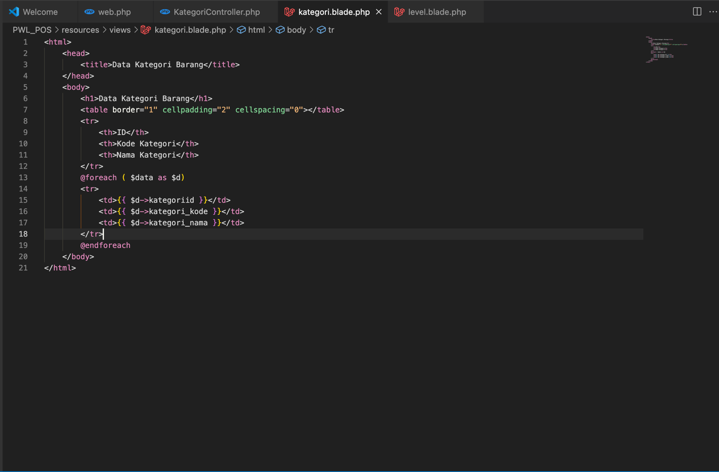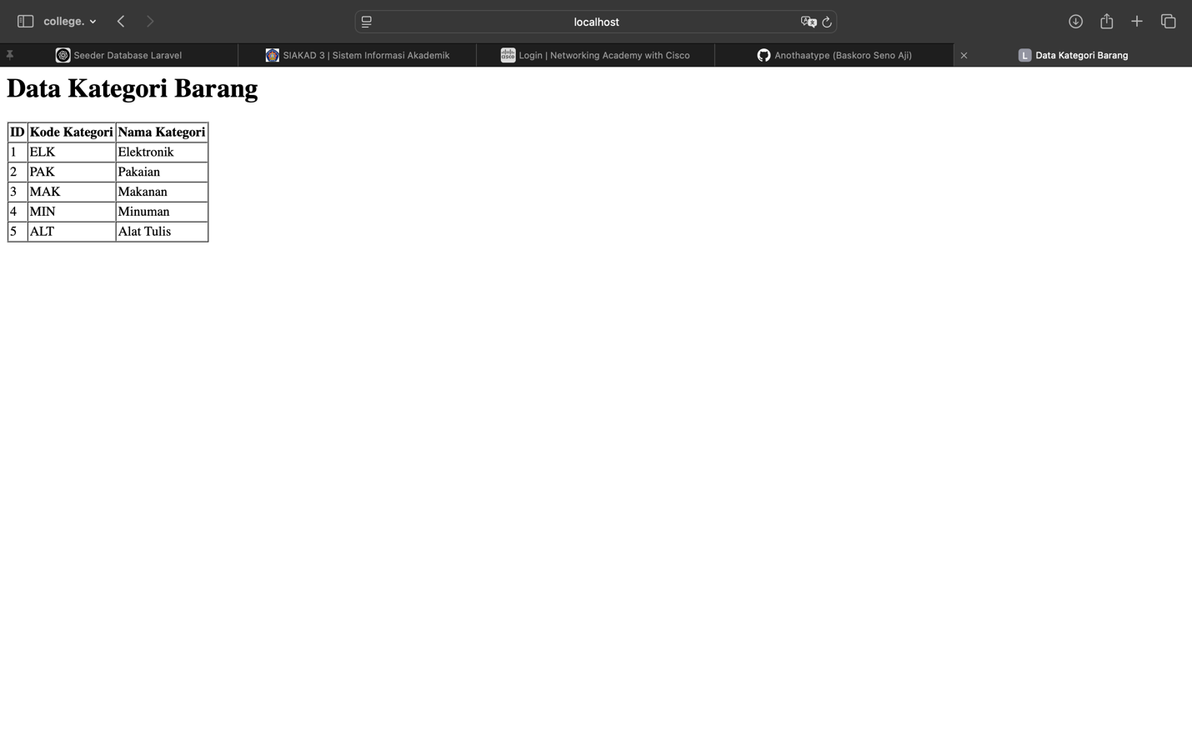

1. In this section we try to implement the select feature from the **Query Builder** by showing it into the table with the html or php in the view terms or file that we already connect to the controller and route, in this section it shown all the data that m_kategori have.

**Eloquent ORM**

Eloquent ORM (Object-Relational Mapping) in Laravel is a feature that makes working with databases easier by allowing you to interact with database tables using PHP objects instead of writing raw SQL queries.

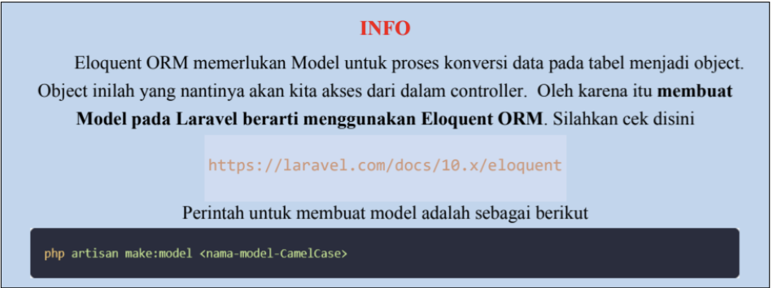

**Praktikum 6 – Implementasi Eloquent Model**

* 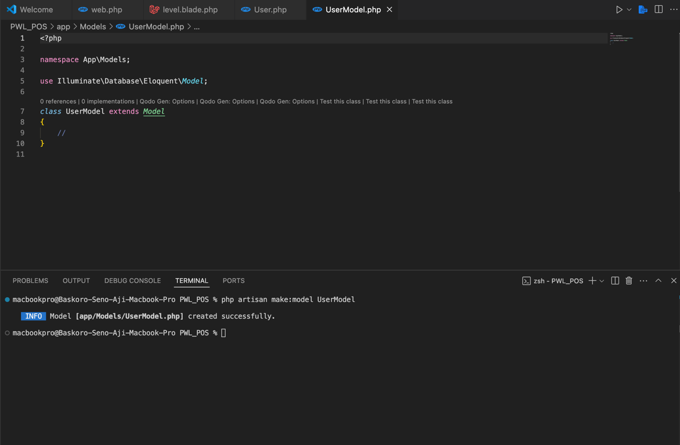First Model Controller

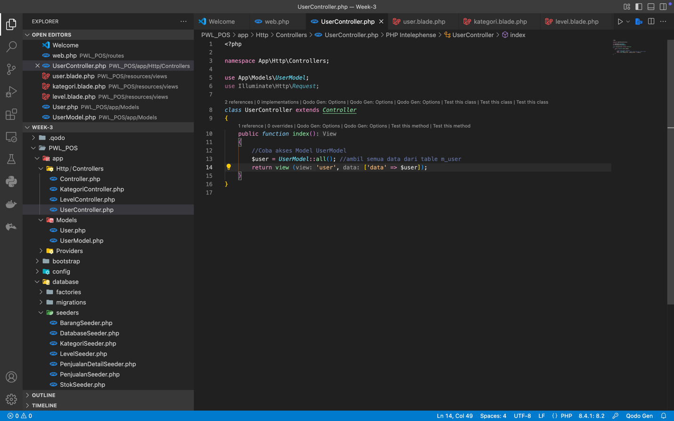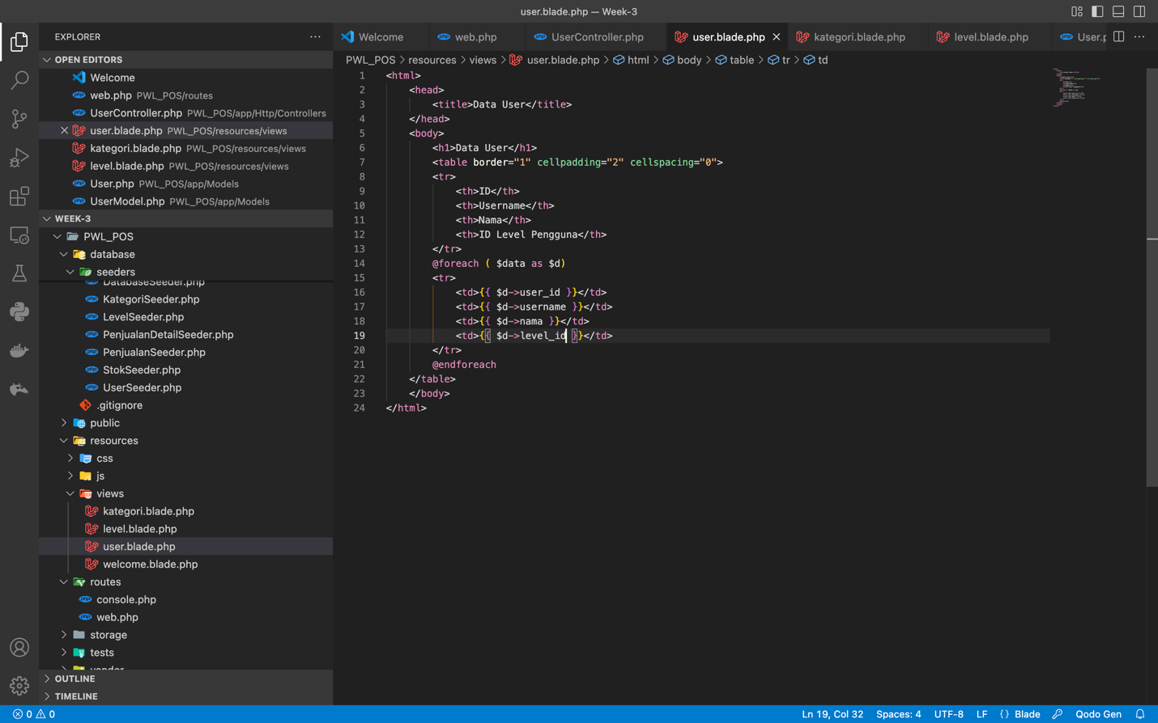

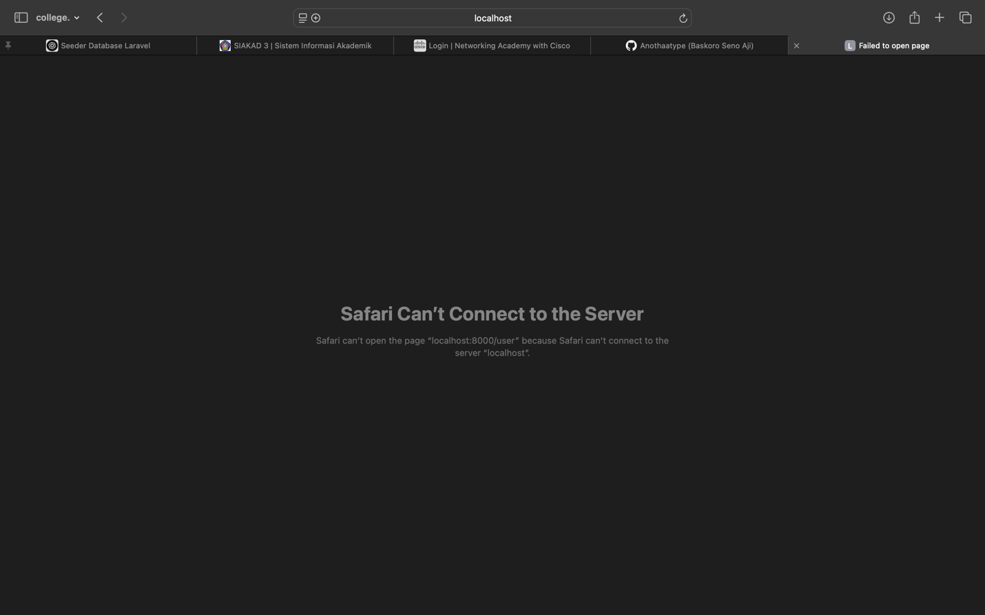

1. When we try to implement the Eloquent model we need to create the route, model (as an object ) and also the view where we can use it as an output, but for the first model we can’t implement it because the model is in the protected areas and we can’t attain or connect into it

* 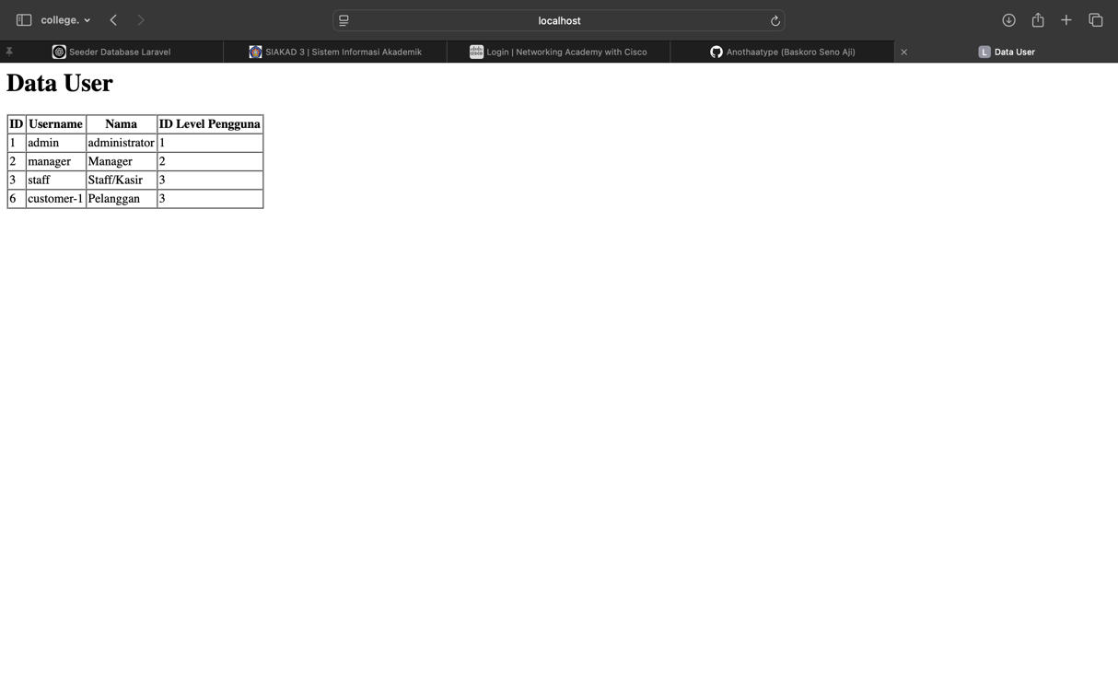Second Model Controller

1. In the second terms of model controller we are implementing The insert() method that used, which directly inserts the data without triggering Eloquent model events.

* Third Model Controller

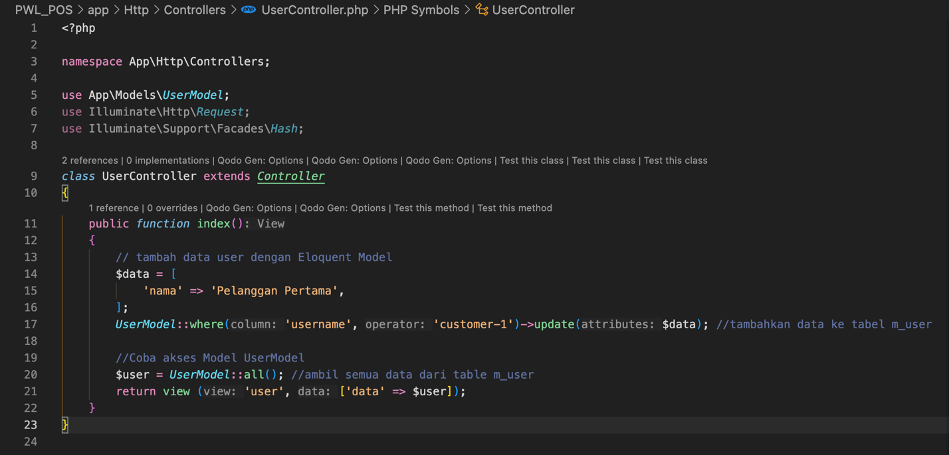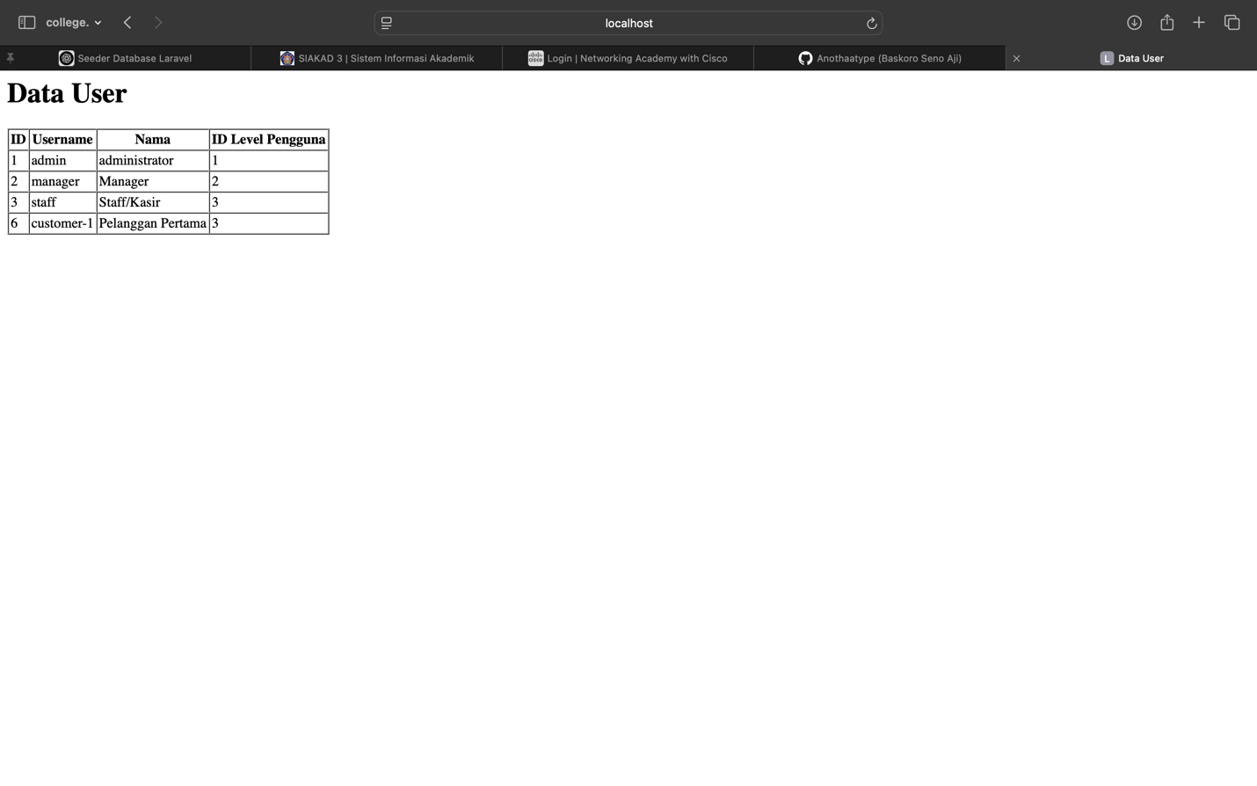

1. In the third terms of model controller we are implementing The Update() method where we modifying the existing data by using an object

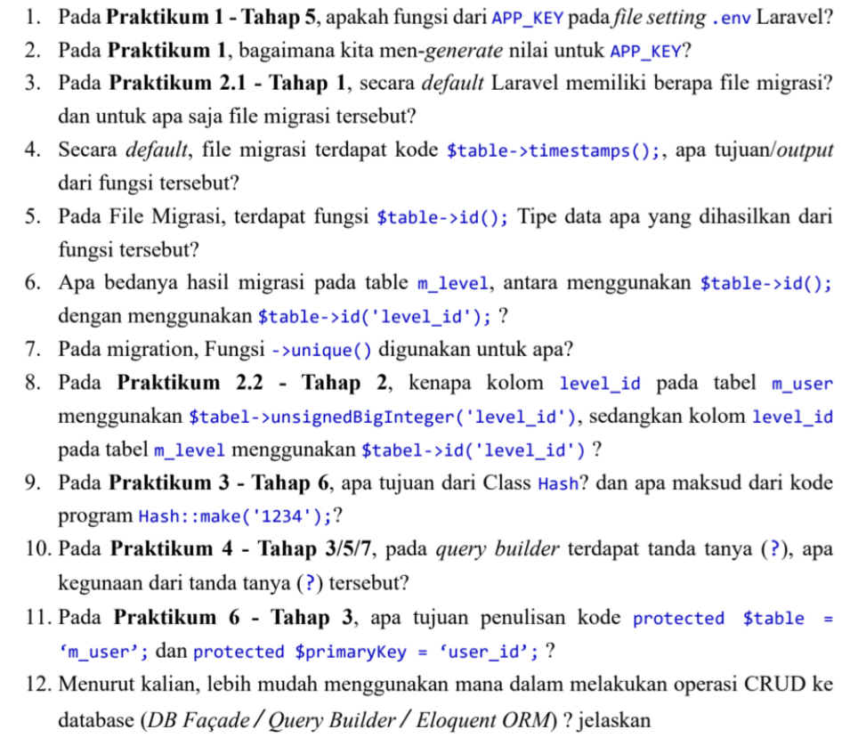**Penutup**

1. Ensuring the security of the application by making sure that encrypted data can only be decrypted by the app with the correct key
2. Php artisan key:generate ( this statement will automatically generate the AppKey into our .env)
3. By the default Laravel have 2 files of migration and The purpose of migration files is to manage the database schema using code, allowing easy creation, updating, or deletion of database structures without writing raw SQL queries.
4. Used for tracking changes in the database records
5. It create a Primary Key where it use BIGINT data type and auto increment
6. The $table->id(); function creates a primary key column named id by default, using the BIGINT data type with auto-increment enabled. On the other hand, $table->id('level_id'); creates a primary key column with the custom name level_id, but it still retains the BIGINT AUTO_INCREMENT properties. The key difference lies in the name of the primary key column.
7. The ->unique() function in Laravel migrations is used to enforce uniqueness on a column. This means that no two records in the table can have the same value for that column. For example, using $table->string('email')->unique(); ensures that email addresses in the table remain unique, preventing duplicate entries.
8. In the m_level table, the $table->id('level_id'); function is used to create a primary key column with the name level_id, which is an auto-incrementing BIGINT field. Meanwhile, in the m_user table, the $table->unsignedBigInteger('level_id'); function is used to define a foreign key column. This foreign key references the level_id primary key from the m_level table. Using unsignedBigInteger ensures that the foreign key matches the data type of the referenced primary key.
9. The Hash class in Laravel is used for password encryption and hashing. The code Hash::make('1234'); generates a secure hashed version of the string '1234' using a hashing algorithm. This approach ensures that passwords are stored securely in the database, making it difficult for attackers to retrieve the original password.
10. The question mark (?) in Laravel’s query builder is used for parameter binding. It acts as a placeholder for values that will be safely inserted into the query. This technique helps prevent SQL injection attacks by ensuring that user input is properly escaped before being executed. For example, in DB::table('users')->where('id', '?')->get();, the question mark will be replaced with the actual ID value safely.
11. The line protected $table = 'm_user'; is used in an Eloquent model to specify the name of the database table associated with the model. This is necessary when the table name does not follow Laravel's default naming convention. Similarly, protected $primaryKey = 'user_id'; is used to define a custom primary key column when the default idcolumn is not used. These configurations help Laravel correctly map the model to the corresponding database table and primary key.
12. among the three options, Eloquent ORM is generally the easiest for performing CRUD (Create, Read, Update, Delete) operations in Laravel. Eloquent allows developers to interact with the database using object-oriented methods instead of writing raw SQL queries. It simplifies database operations by providing built-in functions for handling relationships, validations, and queries.